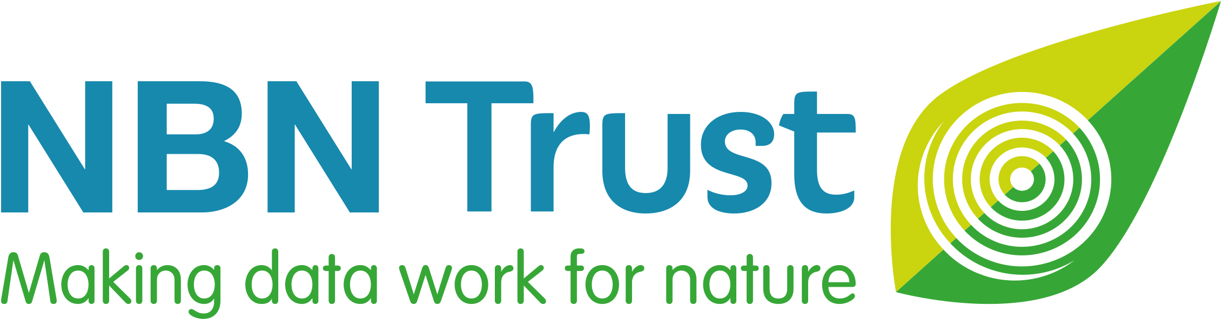

NBN Trust: National Biodiversity Network Trust

We’re a small charity with a big plan – to make data work for nature. For more than 25 years we’ve been making wildlife data accessible, to support better decisions about the natural world and to connect people with nature.

We manage the NBN Atlas, the UK’s largest repository of publicly available biodiversity data, which holds over 304 million records of 51,000 plus species.

The data we share through the NBN Atlas is available because of the many thousands of people who record wildlife. Through their work, these people are making outstanding contributions and helping to improve our understanding of the natural world in the UK.
We want to recognise significant achievement and celebrate success in wildlife recording and information sharing in the UK. So, in 2015, we established a national award scheme in partnership with the Biological Records Centre and the National Forum for Biological Recording. That scheme is the NBN Awards for Wildlife Recording.
NBN Newcomer Award 2026

- Do you know someone who is new to recording wildlife but is already making a difference, increasing our understanding of nature in the UK?

- If you think they are deserving of recognition, why not nominate them for an NBN Newcomer Award by answering just 3 simple questions?

- Anyone can make a nomination, and you can even nominate yourself!

- You have until Monday 18 May 2026 to submit your nomination.

- The NBN Award winners will be announced at the NBN Conference in November.

- Please help us to spread the word – use #NBNawards26 on social media, and direct others to: https://bit.ly/NBNawards26nominations for more information about all seven categories in the NBN Awards for Wildlife Recording 2026.

This category is generously supported by:

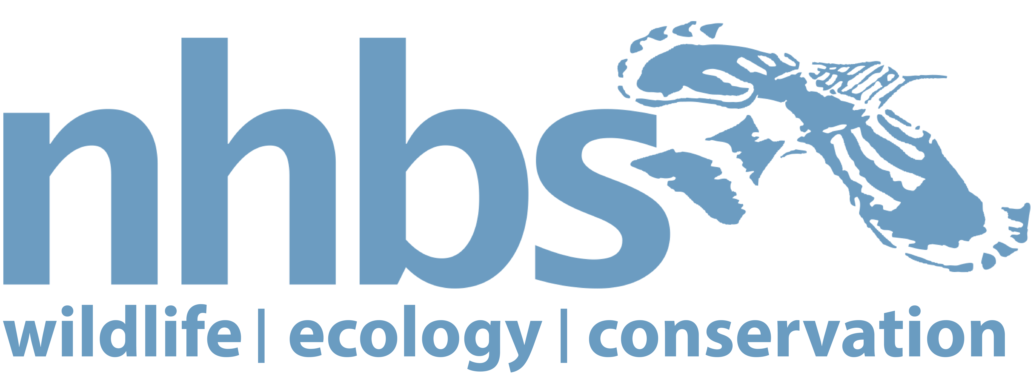
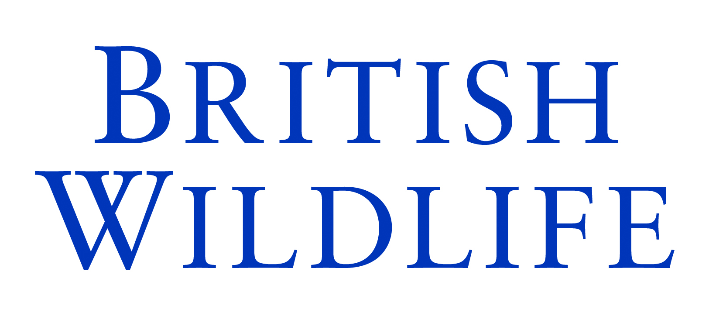

NAME OF NOMINEE:
Nominee’s email address:
Nominee’s phone number:
Nominee’s social media name/handle (if applicable):
REASONS FOR NOMINATION:
Please describe the contribution of the nominee and reasons for nomination. The NBN Awards Committee can only make its decision based on the information you supply, so please give as much detail as possible using the three headings below and the suggested prompts and examples.
The NBN Awards Committee may ask for supplementary information to be supplied.

Building Networks and Development (300 words maximum)

For example:
- Is the nominee a member of any wildlife groups? If yes, for how long?
- What species identification training have they undertaken?
- What wildlife recording skills have they gained?
- Are they encouraging others to record wildlife and promoting its value?

Wildlife Records and Sharing Data (300 words maximum)

For example:
- Are the nominee’s records filling gaps in knowledge of certain species or locations?
- Which species do they record?
- Are their records being shared openly via iRecord, iSpot, iNaturalistUK or in some other way?
- Are the nominee’s records shared with a Local Environmental Record Centre, another organisation and/or via the NBN Atlas?

Uniqueness and Other Considerations (300 words maximum)

For example:
- Is anyone else recording similar species or recording wildlife in the same location?
- Is the nominee self-taught in species identification?
- Are they a volunteer? How much time do they commit per month?
- How long has the nominee been involved in wildlife recording?

Note: You may attach supporting documents, if required. [5 maximum]

YOUR NAME:
Your relationship to the Nominee:
Your email address:
Your phone number:
☐ Please mark this box, if you would like to remain anonymous throughout the nomination
and Award process.

And finally, please could you tell us where you heard about these NBN Awards?
(Please mark all that apply)

☐ NBN Trust website ☐ Network News ☐ NBN Trust Facebook

☐ Bluesky ☐ LinkedIn ☐ Other Facebook Group

☐ Instagram ☐ Through my job ☐ Wildlife group/organisation

☐ Other

If other, please specify_________________________________________________________

Please email this completed nomination form by Monday 18 May 2026 to: support@nbn.org.uk
Thank you for taking the time to make this nomination and celebrating the commitment of
someone who is new to recording wildlife but is already making a difference.

What happens next?
The shortlisted nominees will be announced at the beginning of September and the winners and those highly commended at the NBN Conference in November.

You can receive updates about the NBN Awards by signing up to our monthly Network News or by following us on social media.



