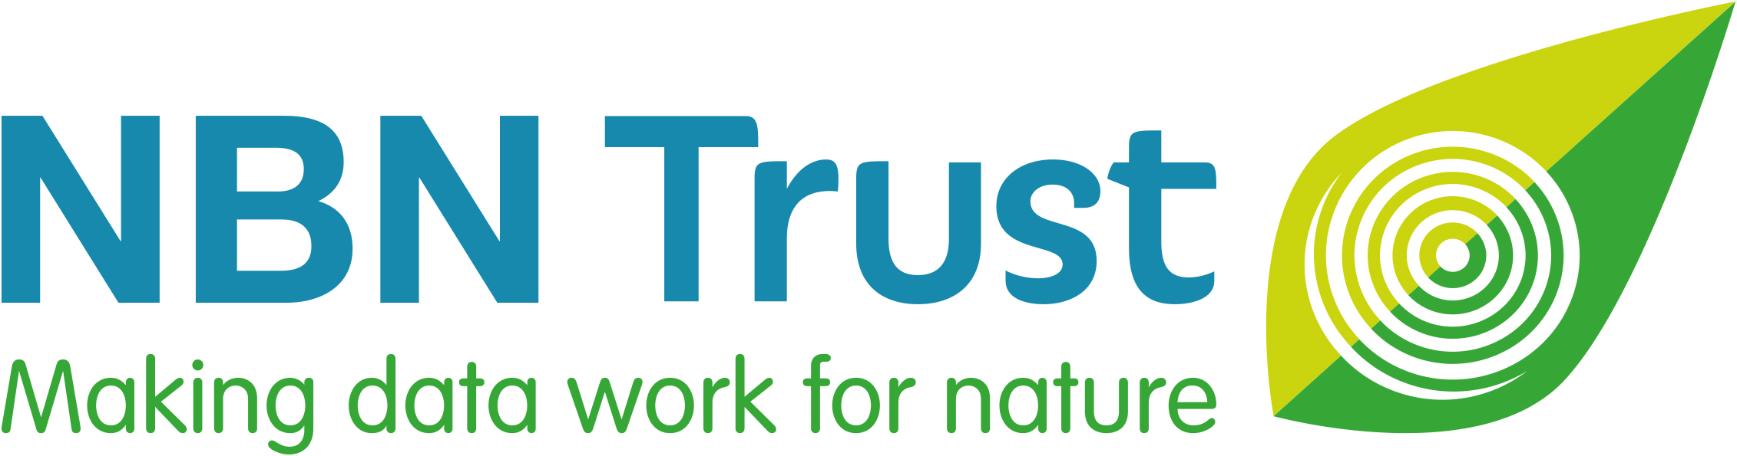

NBN Lifetime Achievement Award 2025

- Do you know someone who has been recording wildlife in the UK for many years?

- If you think they are deserving of recognition, why not nominate them for an NBN Lifetime Achievement Award by answering just 4 simple questions?

- Anyone can make a nomination, and you can even nominate yourself!

- You have until Monday 21 April 2025 to submit your nomination.

- The NBN Award winners will be announced at the National Biodiversity Network Conference in November.

- Please help us to spread the word – use #NBNawards25 on social media, and direct others to: bit.ly/NBNawards25 for more information about all seven NBN Awards for Wildlife Recording 2025.

Sponsored by:
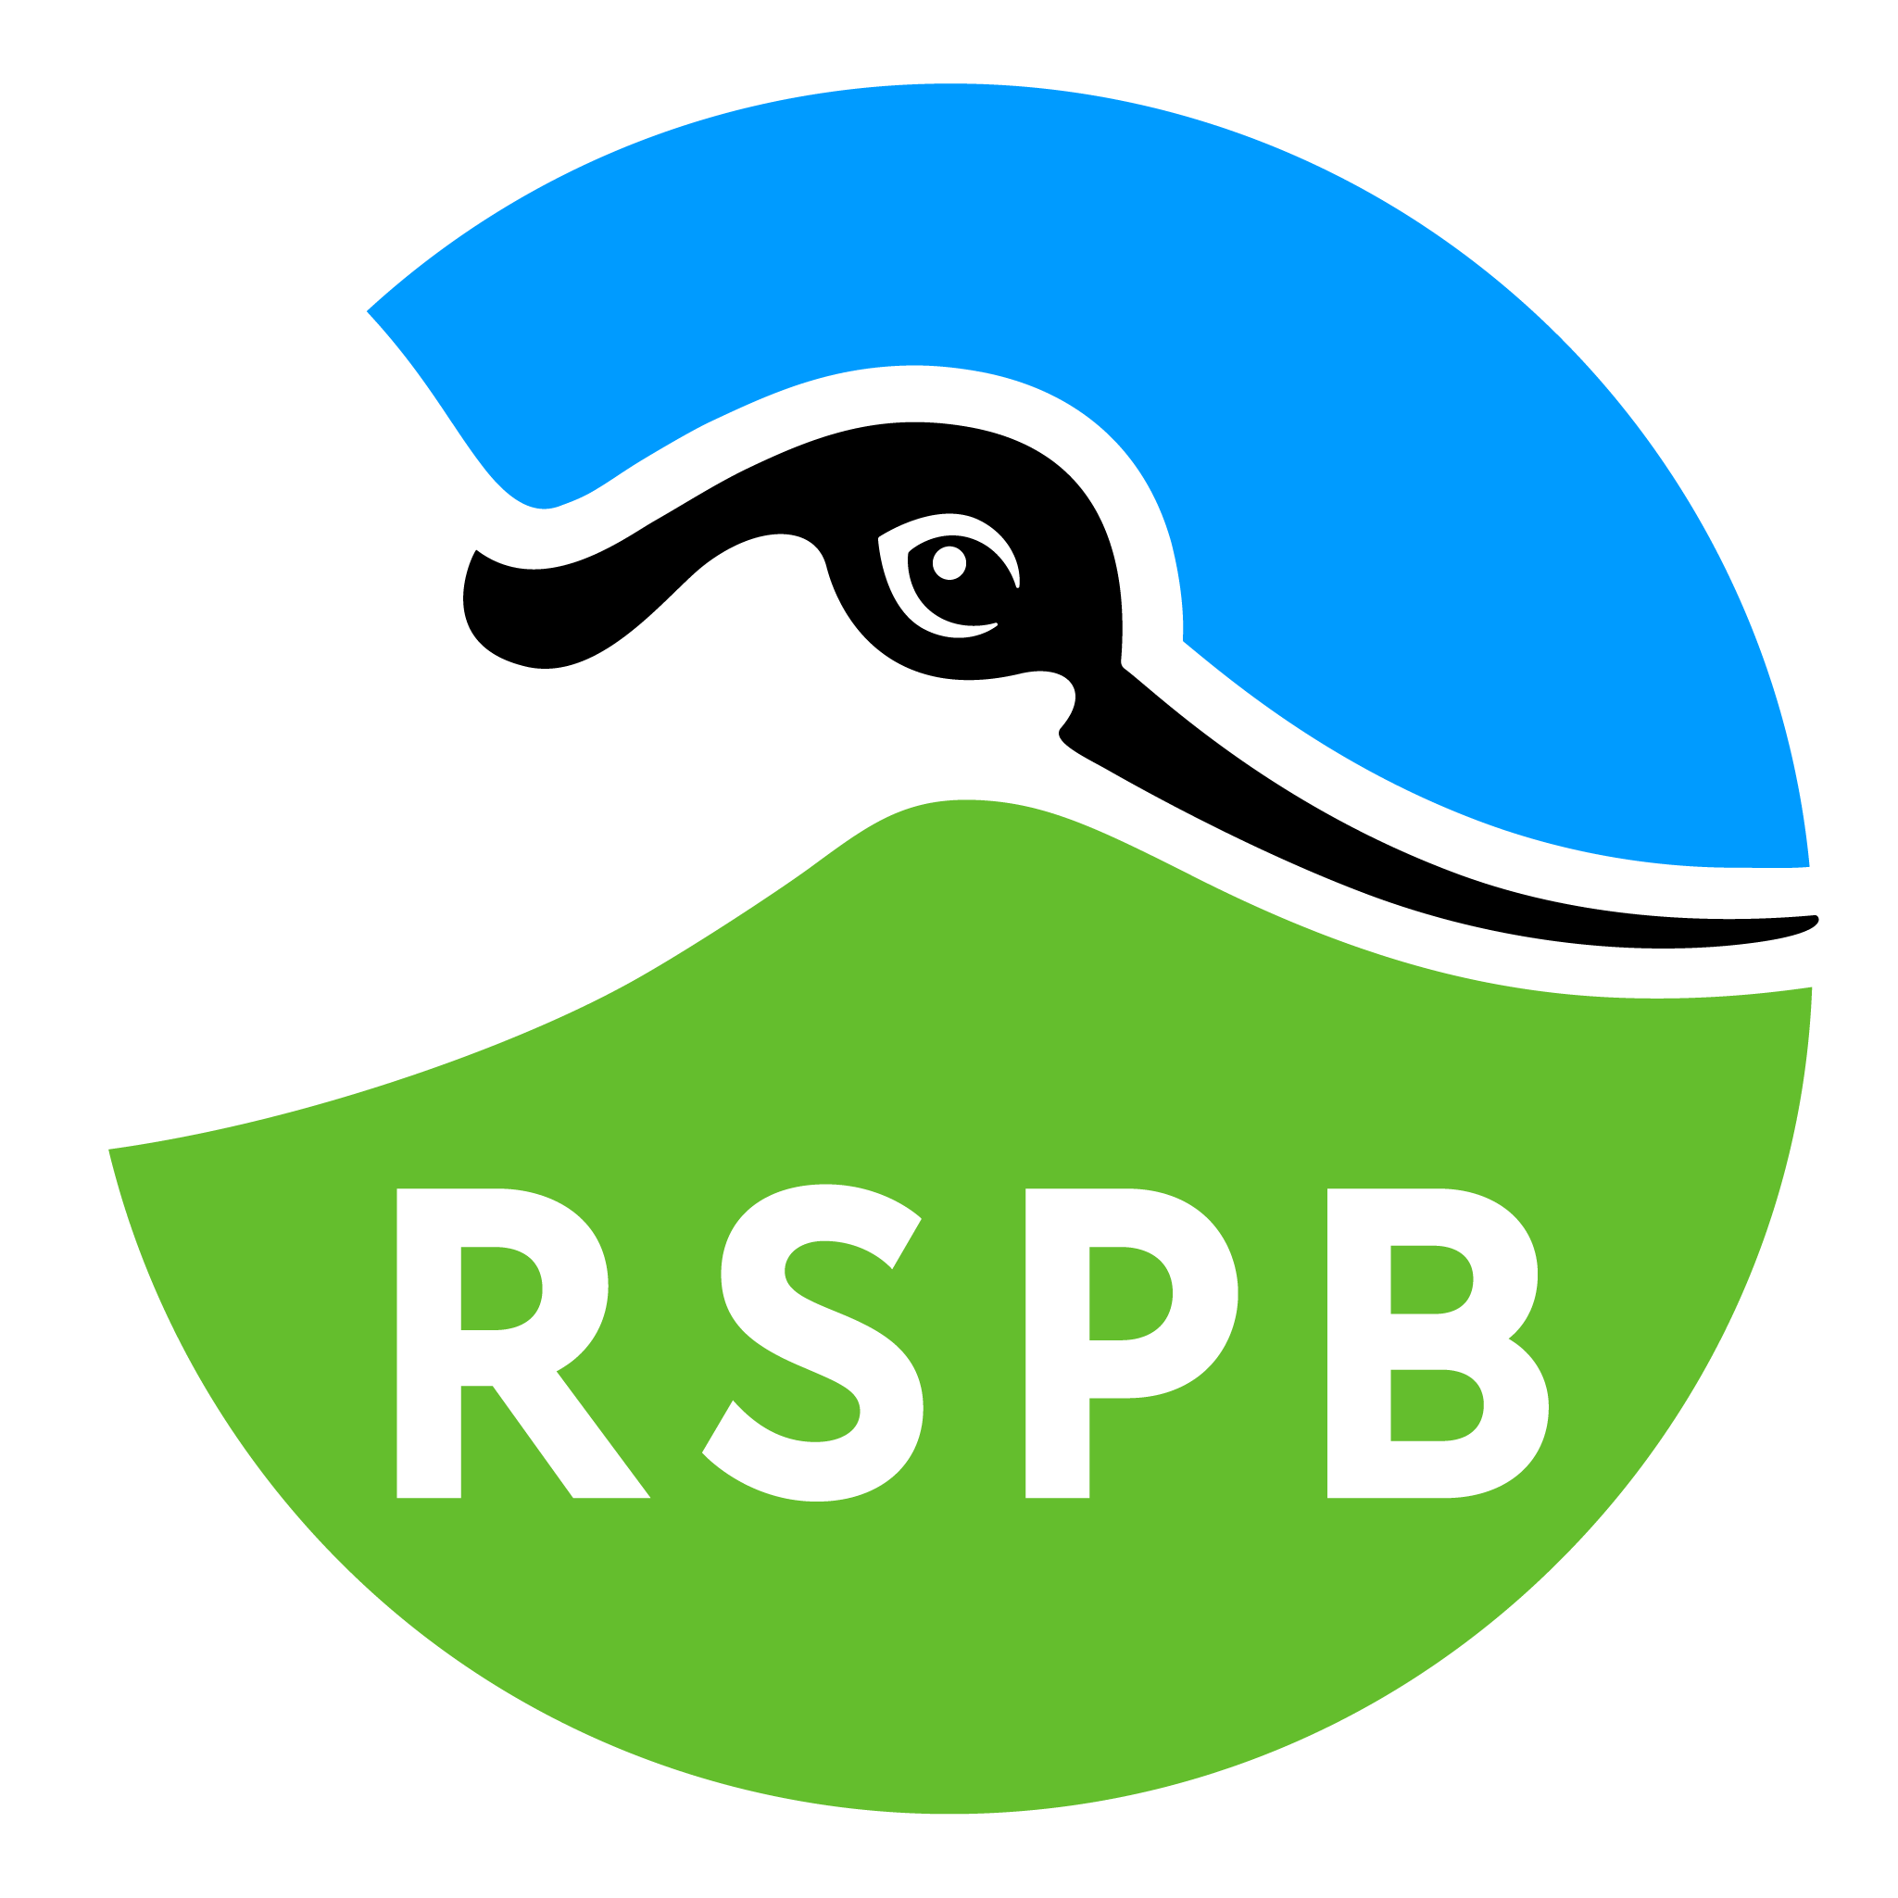

The National Biodiversity Network Trust (NBN Trust) is very grateful to the Royal Society for the Protection of Birds (RSPB) for their generous sponsorship of this NBN Verifier’s Award 2025.

National Biodiversity Network Trust

We’re a small charity with a big plan – to make data work for nature. For more than 20 years we’ve been making wildlife data accessible, to support better decisions about the natural world and to connect people with nature.

We manage the NBN Atlas, the UK’s largest repository of publicly available biodiversity data – holding well over 250 million records of 50,000 plus species – from ladybirds, red squirrels and toads through to rare lichen, fungi and endangered insects.

NAME OF NOMINEE:
Nominee’s email address:
Nominee’s phone number:
Nominee’s social media name/handle:
REASONS FOR NOMINATION:
Please describe the contribution of the nominee and reasons for nomination. The NBN Awards Committee can only make its decision based on the information you supply, so please give as much detail as possible using the four headings below and the suggested prompts and examples.
The NBN Awards Committee may ask for supplementary information to be supplied.

Wildlife Records and Sharing Data (300 words maximum)

For example:
- How long has the nominee been recording wildlife?
- Approximately how many wildlife records has the nominee made – several hundred or several thousand?
- Which species do they record?
- Are their records filling gaps in knowledge of certain species or locations?
- Are the nominee’s records being shared openly via iRecord, iSpot, iNaturalistUK or in some other way?
- Are their records shared with a Local Environmental Record Centre, another organisation and/or via the NBN Atlas?

Engagement and Training (300 words maximum)

For example:
- Are they increasing the range and diversity of people interested in nature?
- Has the nominee encouraged others to record wildlife?
- Are they training or mentoring others and increasing other people’s wildlife identification and recording skills?

Impact and Influence (300 words maximum)

For example:
- Are the nominee’s wildlife records being used in local or regional plans, affecting decisions about conservation?
- Has the nominee written books or developed new tools/apps or species identification guides and resources?
- Have the nominee’s own practices been adopted as the wildlife-sector’s standard?
- Has the nominee started any new recording schemes?

Uniqueness and Other Considerations (300 words maximum)

For example:
- Is the nominee regarded as the UK-expert on any particular species?
- Are they a volunteer?
- Have they held a notable position within a wildlife organisation – Founder, Trustee, Chair, CEO or Director?

Note: you may attach supporting documents, if required. [5 maximum]
YOUR NAME:
Your relationship to the Nominee:
Your email address:
Your phone number:
Your social media name/handle:
☐ Please mark this box, if you would like to remain anonymous throughout the nomination
and Award process.

And finally, please could you tell us where you heard about these NBN Awards?
(Please mark all that apply)

☐ NBN website ☐ Network News ☐ Facebook

☐ Bluesky ☐ LinkedIn ☐ Wildlife group/organisation

☐ Instagram ☐ Through my job ☐ Other

If other, please specify_________________________________________________________

Please email this completed nomination form by Monday 21 April 2025 to: support@nbn.org.uk
Thank you for taking the time to make this nomination and celebrating the commitment of
someone who has been recording UK wildlife for many years.

You can receive updates about the NBN Awards for Wildlife Recording 2025 by searching #NBNawards25 on social media.

