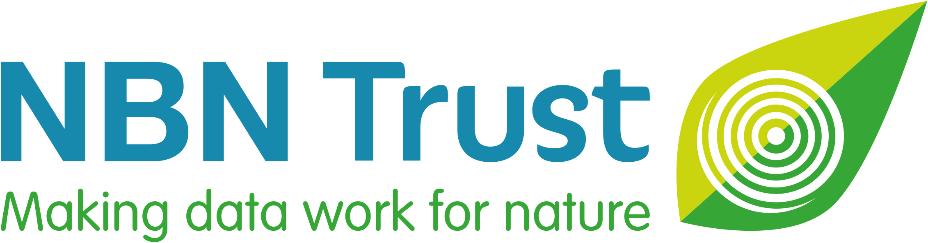

NBN Award for Marine Wildlife Recording 2024

- Do you know someone who records marine or coastal wildlife who is making a difference, increasing our understanding of nature in the UK?

- If you think they are deserving of recognition, why not nominate them for an NBN Marine Award by answering just 4 simple questions?

- Anyone can make a nomination, and you can even nominate yourself!

- You have until Wednesday 3 April 2024 to submit your nomination.

- The NBN Award winners will be announced at the National Biodiversity Network Conference in November.

- Please help us to spread the word – use #NBNawards24 on social media, and direct others to: bit.ly/NBNawards24 for more information about all seven NBN Awards for Wildlife Recording 2024.

Sponsored by:

The National Biodiversity Network Trust (NBN Trust) is very grateful to Habitat Aid and
William Collins for their generous sponsorship of this NBN Award for Marine Wildlife Recording 2024.

National Biodiversity Network Trust

We’re a small charity with a big plan – to make data work for nature. For more than 20 years we’ve been making wildlife data accessible, to support better decisions about the natural world and to connect people with nature.

We manage the NBN Atlas, the UK’s largest repository of publicly available biodiversity data – holding well over 250 million records of 50,000 plus species – from ladybirds, red squirrels and toads through to rare lichen, fungi and endangered insects.

NAME OF NOMINEE:
Nominee’s email address:
Nominee’s phone number:
Nominee’s social media name/handle:
REASONS FOR NOMINATION:
Please describe the contribution of the nominee and reasons for nomination. The NBN Awards Committee can only make its decision based on the information you supply, so please give as much detail as possible using the four headings below and the suggested prompts and examples.
The NBN Awards Committee may ask for supplementary information to be supplied.

Wildlife Records and Sharing Data (300 words maximum)

For example:
- Are the nominee’s records filling gaps in knowledge of certain marine or coastal species or locations?
- Which species do they record?
- Are their records being shared openly via iRecord, iSpot, iNaturalistUK or in some other way?
- Are the nominee’s records shared with a Local Environmental Record Centre, another organisation and/or via the NBN Atlas?

Engagement and Training (300 words maximum)

For example:
- Is the nominee increasing the range and diversity of people interested in marine or coastal wildlife?
- Are they encouraging others to record marine and/or coastal wildlife?
- Is the nominee training others and increasing other people’s wildlife identification and recording skills?

Impact and Influence (300 words maximum)

For example:
- Are the nominee’s marine and/or coastal wildlife data being used in local plans, affecting decisions about conservation?
- Has the nominee developed new tools or resources, such as species identification guides or apps?
- Has the nominee started a new group or organisation?

Uniqueness and Other Considerations (300 words maximum)

For example:
- Is anyone else recording the same marine and/or coastal species or in similar locations?
- Is the nominee self-taught in species identification?
- Are they a volunteer? How much time do they commit per month?
- How long has the nominee been recording marine or coastal wildlife and how much time do they spend recording?

Note: you may attach supporting documents, if required. [5 maximum]
YOUR NAME:
Your relationship to the Nominee:
Your email address:
Your phone number:
Your social media name/handle:
☐ Please mark this box, if you would like to remain anonymous throughout the nomination
and Award process.

And finally, please could you tell us where you heard about these NBN Awards?
(Please mark all that apply)

☐ NBN website ☐ Network News ☐ Facebook

☐ X (formerly Twitter) ☐ LinkedIn ☐ Wildlife group/organisation

☐ Instagram ☐ Through my job ☐ Other

If other, please specify_________________________________________________________

Please email this completed nomination form by Wednesday 3 April 2024 to: support@nbn.org.uk
Thank you for taking the time to make this nomination and celebrating the commitment of
someone who records marine or coastal wildlife in the UK.

You can receive updates about the NBN Awards for Wildlife Recording 2024 by searching #NBNawards24 on social media.

