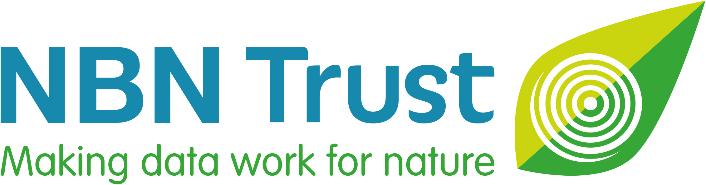

NBN Young Person’s Award 2024

- Do you know a young person (between the ages of 11 and 20 years old) who records wildlife and is making a difference, increasing our understanding of nature in the UK?

- If you think they are deserving of recognition, why not nominate them for an NBN Young Person’s Award by answering just 3 simple questions?

- Anyone can make a nomination, and you can even nominate yourself!

- You have until Wednesday 3 April 2024 to submit your nomination.

- The NBN Award winners will be announced at the National Biodiversity Network Conference in November.

- Please help us to spread the word – use #NBNawards24 on social media, and direct others to: bit.ly/NBNawards24 for more information about all seven NBN Awards for Wildlife Recording 2024.

Sponsored by:
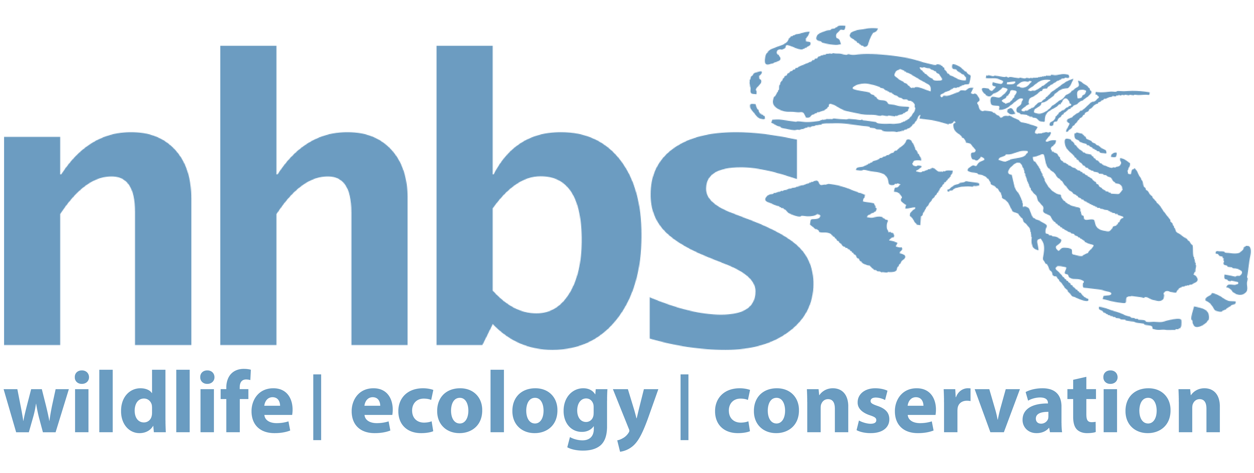
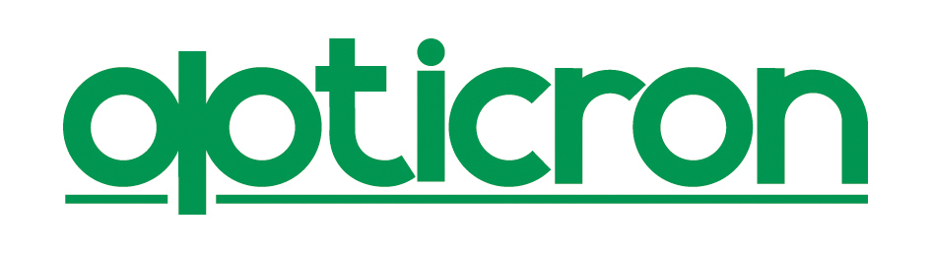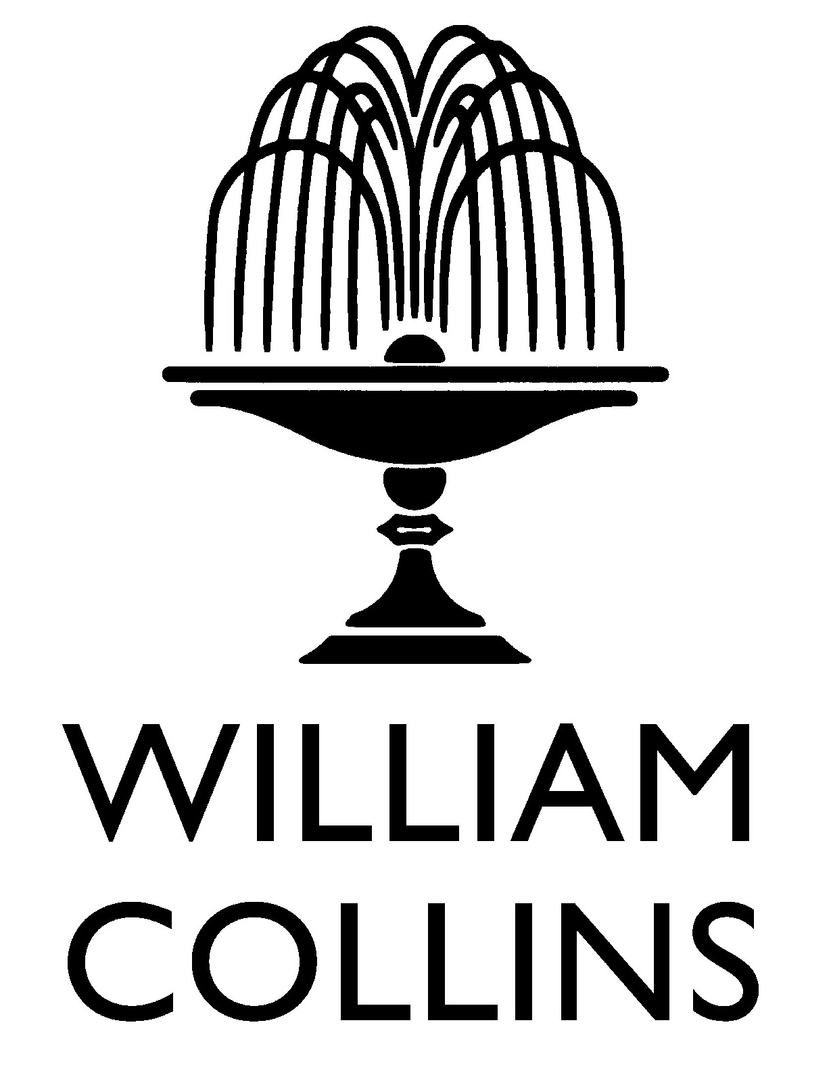

The National Biodiversity Network Trust (NBN Trust) is very grateful to Opticron, William Collins and Natural History Book Service (NHBS) for their generous sponsorship of this NBN Young Person’s Award 2024.

National Biodiversity Network Trust

We’re a small charity with a big plan – to make data work for nature. For more than 20 years we’ve been making wildlife data accessible, to support better decisions about the natural world and to connect people with nature.

We manage the NBN Atlas, the UK’s largest repository of publicly available biodiversity data – holding well over 250 million records of 50,000 plus species – from ladybirds, red squirrels and toads through to rare lichen, fungi and endangered insects.

NAME OF NOMINEE:
Nominee’s age on 30 November 2024:
Nominee’s email address:
Nominee’s social media name/handle:
REASONS FOR NOMINATION:
Please describe the contribution of the nominee and reasons for nomination. The NBN Awards Committee can only make its decision based on the information you supply, so please give as much detail as possible using the three headings below and the suggested prompts and examples.
The NBN Awards Committee may ask for supplementary information to be supplied.

Learning and Commitment (300 words maximum)

For example:
- Is the nominee a committed member of a wildlife group? If yes, for how long?
- Do they volunteer for the wildlife group?
- If yes, how much time do they commit per month?
- What wildlife recording skills have they gained from any training given by the wildlife group?

Wildlife Records and Sharing Data (300 words maximum)

For example:
- Is the nominee actively and regularly recording wildlife – either as a member of a group or independently?
- If yes, which species do they record?
- Are the nominee’s records filling gaps in knowledge of certain species or locations?
- Are their records being shared openly via iRecord, iSpot, iNaturalistUK or in some other way?
- Are the nominee’s records shared with a Local Environmental Record Centre, another organisation and/or via the NBN Atlas?

Uniqueness and Other Considerations (300 words maximum)

For example:
- Is the nominee an ambassador/role-model for other young wildlife recorders?
- Is the nominee encouraging others to get involved in recording – either face to face, via social media, or through their own blog or website?

Note: you may attach supporting documents, if required. [5 maximum]
YOUR NAME:
Your relationship to the Nominee:
Your email address:
Your phone number:
Your social media name/handle:
☐ Please mark this box, if you would like to remain anonymous throughout the nomination
and Award process.

And finally, please could you tell us where you heard about these NBN Awards?
(Please mark all that apply)

☐ NBN website ☐ Network News ☐ Facebook

☐ X (formerly Twitter) ☐ LinkedIn ☐ Wildlife group/organisation

☐ Instagram ☐ Through my job ☐ Other

If other, please specify_________________________________________________________

Please email this completed nomination form by Wednesday 3 April 2024 to: support@nbn.org.uk
Thank you for taking the time to make this nomination and celebrating the commitment of a young person who records wildlife in the UK.

You can receive updates about the NBN Awards for Wildlife Recording 2024 by searching #NBNawards24 on social media.

