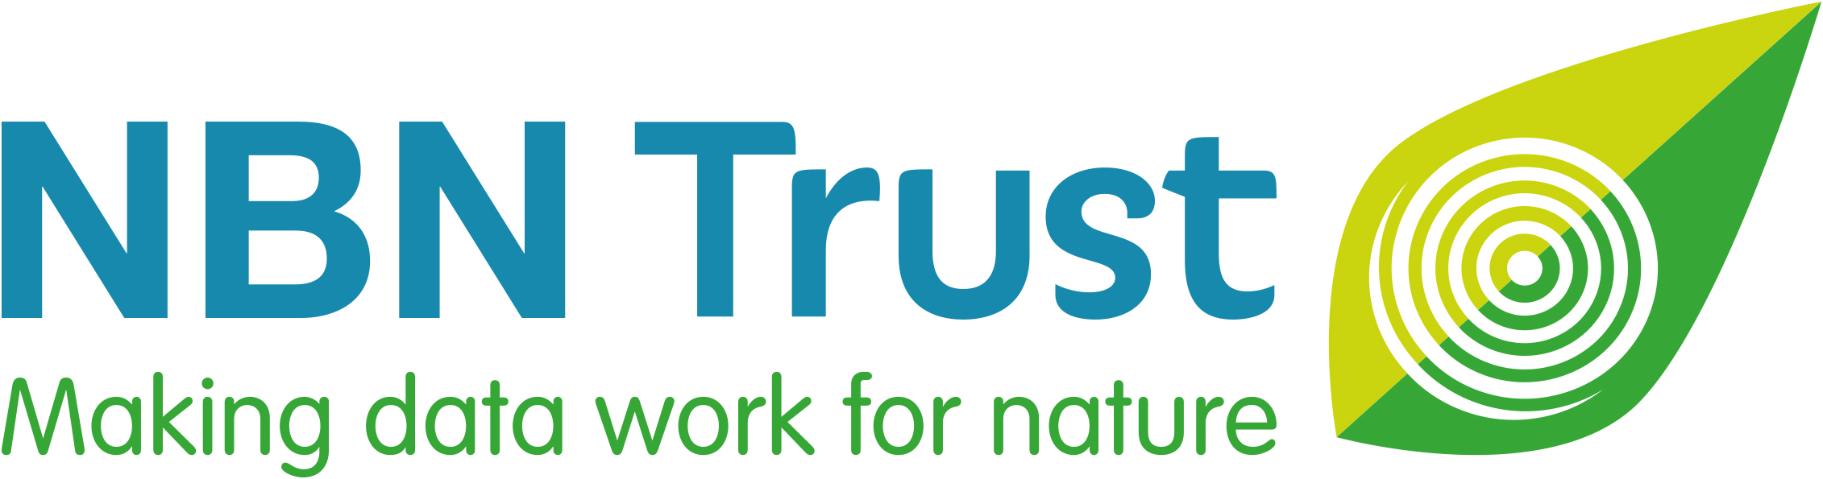

NBN Verifier’s Award 2024

- Do you know someone who verifies wildlife records in the UK?

- If you think they are deserving of recognition, why not nominate them for an NBN Verifier’s Award by answering just 3 simple questions?

- Anyone can make a nomination, and you can even nominate yourself!

- You have until Wednesday 3 April 2024 to submit your nomination.

- The NBN Award winners will be announced at the National Biodiversity Network Conference in November.

- Please help us to spread the word – use #NBNawards24 on social media, and direct others to: bit.ly/NBNawards24 for more information about all seven NBN Awards for Wildlife Recording 2024.

National Biodiversity Network Trust

We’re a small charity with a big plan – to make data work for nature. For more than 20 years we’ve been making wildlife data accessible, to support better decisions about the natural world and to connect people with nature.

We manage the NBN Atlas, the UK’s largest repository of publicly available biodiversity data – holding well over 250 million records of 50,000 plus species – from ladybirds, red squirrels and toads through to rare lichen, fungi and endangered insects.

NAME OF NOMINEE:
Nominee’s email address:
Nominee’s phone number:
Nominee’s social media name/handle:
REASONS FOR NOMINATION:
Please describe the contribution of the nominee and reasons for nomination. The NBN Awards Committee can only make its decision based on the information you supply, so please give as much detail as possible using the three headings below and the suggested prompts and examples.
The NBN Awards Committee may ask for supplementary information to be supplied.

Verifying Wildlife Records (300 words maximum)

For example:
- Which recording scheme(s) is the nominee verifying wildlife records for?
- Which species do they verify?
- Does the nominee also verify records from iRecord, iSpot, iNaturalistUK and/or from Local Environmental Record Centres?
- For which county do they verify records, or is it on a national UK-level?
- How much time does the nominee spend, per month, verifying records?

Impact and Influence (300 words maximum)

For example:
- Are the wildlife data which the nominee has verified being used in local, regional or national planning, affecting decisions about conservation in the UK?
- Does the nominee provide feedback to wildlife recorders about their records and how the records are used?
- Does the nominee mentor or help train others in species identification?
- Do they contribute their species knowledge to identification resources, such as identification guides or apps?

Uniqueness and Other Considerations (300 words maximum)

For example:
- Is anyone else in the UK verifying the same group(s) of species?
- Are they a volunteer?
- How long has the nominee been committed to verifying wildlife records?

Note: you may attach supporting documents, if required. [5 maximum]
YOUR NAME:
Your relationship to the Nominee:
Your email address:
Your phone number:
Your social media name/handle:
☐ Please mark this box, if you would like to remain anonymous throughout the nomination
and Award process.

And finally, please could you tell us where you heard about these NBN Awards?
(Please mark all that apply)

☐ NBN website ☐ Network News ☐ Facebook

☐ X (formerly Twitter) ☐ LinkedIn ☐ Wildlife group/organisation

☐ Instagram ☐ Through my job ☐ Other

If other, please specify_________________________________________________________

Please email this completed nomination form by Wednesday 3 April 2024 to: support@nbn.org.uk
Thank you for taking the time to make this nomination and celebrating the commitment of
someone who verifies wildlife records in the UK.

You can receive updates about the NBN Awards for Wildlife Recording 2024 by searching #NBNawards24 on social media.

