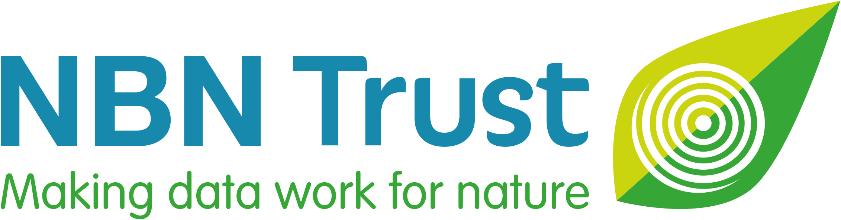
NBN Award for Wildlife Recording – Marine 2022

Sponsored by:

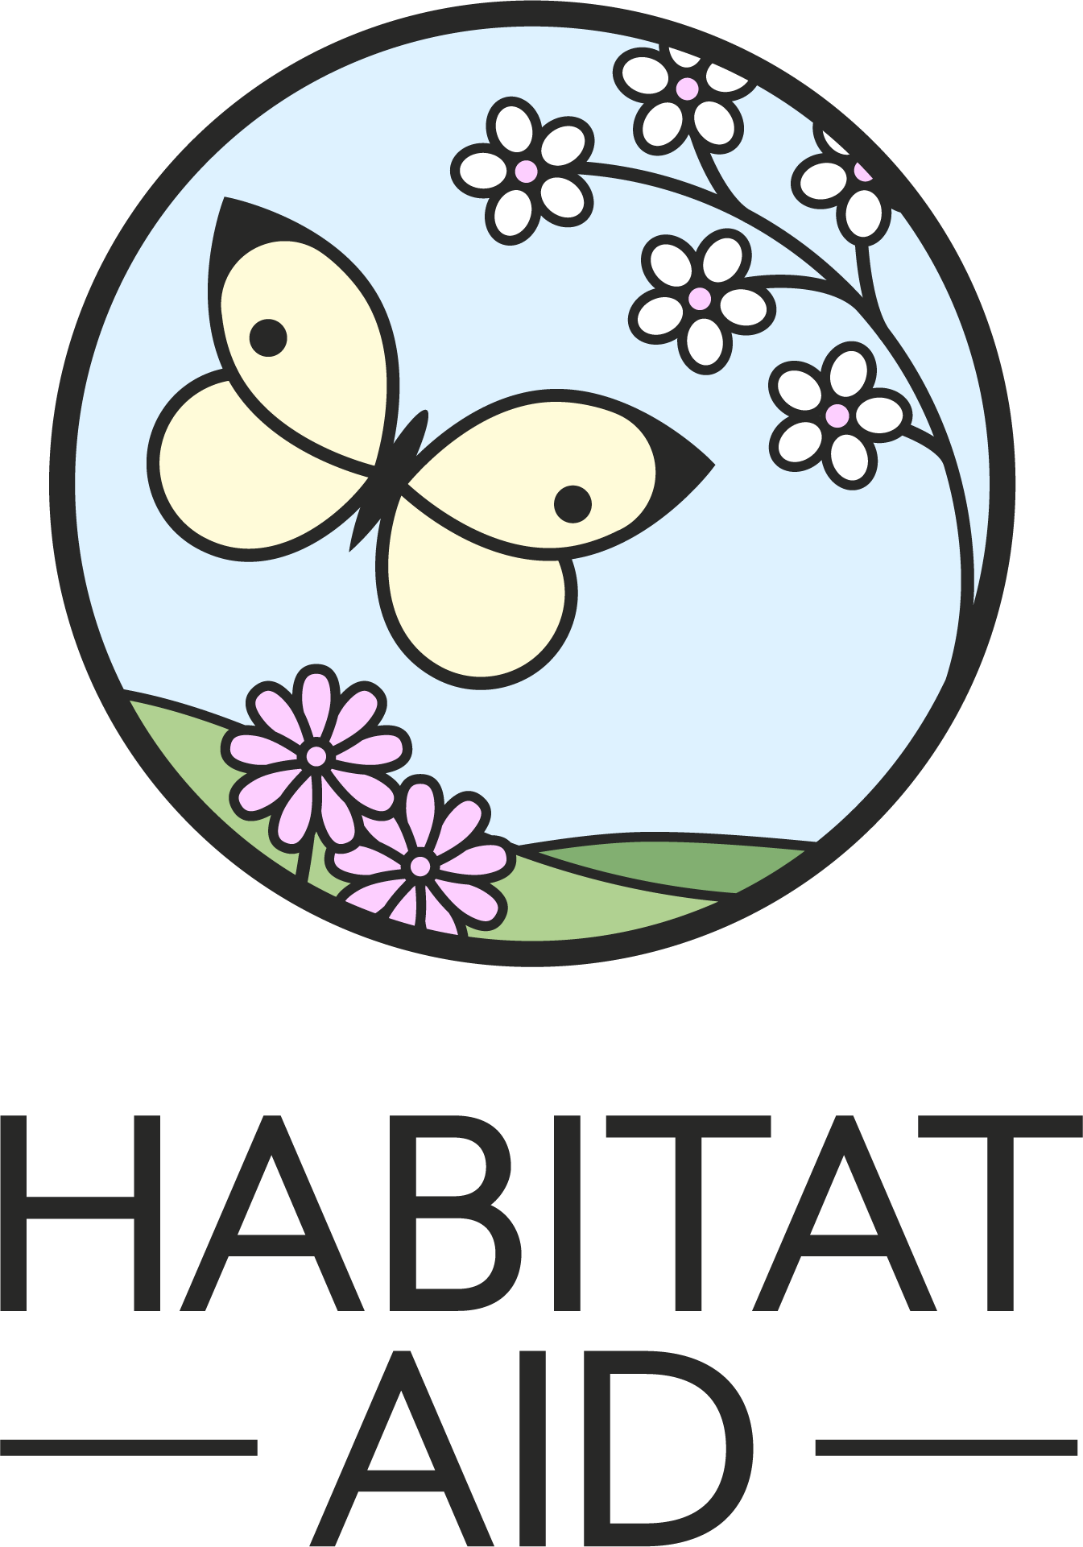

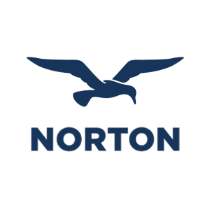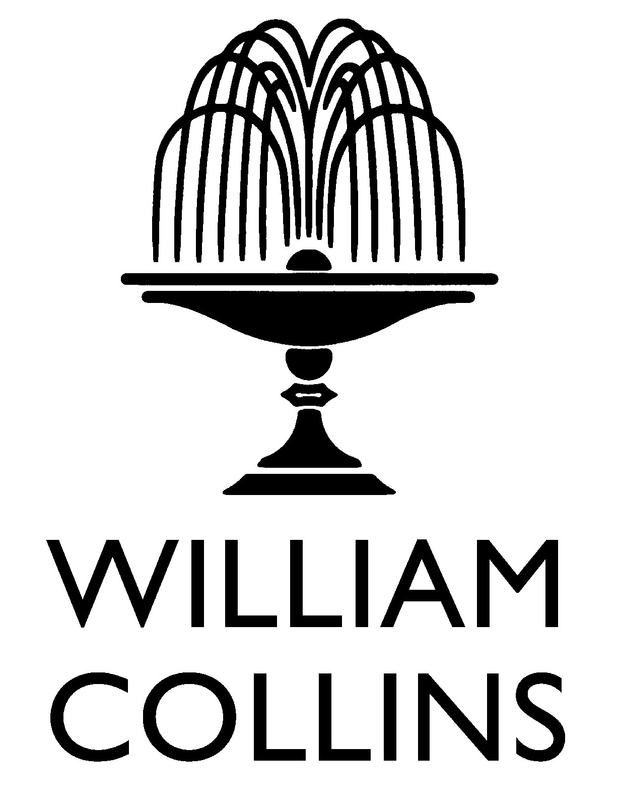

The National Biodiversity Network Trust (NBN Trust) is now accepting nominations for the 2022 Awards that celebrate outstanding contributions to wildlife recording and improving our understanding of nature in the UK. These awards were developed in 2015 by the National Biodiversity Network Trust, the National Forum for Biological Recording and the Biological Records Centre.

This NBN Award – Marine is generously sponsored by Habitat Aid, the Michael Hoppen Gallery, William Collins, Bird Photographer of the Year and W.W. Norton & Company.

The 2022 award categories are:
- NBN Award for Wildlife Recording – Terrestrial (open to individuals 21 years +)
- NBN Award for Wildlife Recording – Marine (open to individuals 21 years +)
- NBN Group Award (no age restrictions)
- NBN Young Person’s Award (open to individuals aged 11-20)
- NBN Newcomer Award (open to individuals 21 years +)

Eligibility for award categories:
- The Young Person’s Award will be given to an individual who is between the ages of 11 and 20 on 30 November 2022.
- The Terrestrial, Marine and Newcomer Awards will be given to an individual 21 years old and above.
- The Group Award will be given to a group or organisation with members of any age.

The Awards Committee will consider the significance of the contribution (voluntary or otherwise) made to wildlife recording and/or improving our understanding of the UK’s biodiversity. This could include filling geographic or taxonomic gaps in our knowledge, encouraging and facilitating participation, verifying records, teaching or mentoring recorders, or creating and sharing tools and resources to support wildlife recording and increasing participation. More information about the awards and additional nomination forms are available on the NBN website: bit.ly/NBNawards22

To nominate the same person for different award categories, please use the relevant nomination forms for each category. If you wish to nominate more than one person for the same award category, please use a separate form for each nominee. Anyone is eligible to make nominations, you may even nominate yourself! The awards will be presented at a special ceremony that is part of the NBN’s annual conference, on Wednesday 9 November.
Nominations close on Sunday 17 July 2022. The Awards Committee may ask for supplementary material to be supplied for short‐listed candidates.

NAME OF NOMINEE:
Address:

Phone:
E-mail:
REASONS FOR NOMINATION:
Please describe the contribution of the nominee and reasons for nomination. Please give as much detail as possible using the four headings below. The Awards Committee can only make its decision based on the information you supply, so the more relevant detail you provide under each heading, the more likely your nominee will do well in these Awards.
Record Generation and Open Data
Is the nominee making new records? Do they cover one taxonomic group or several? Has the work plugged gaps in taxonomic or geographical knowledge? Are the records being shared openly? Are they on the NBN Atlas? (300 words maximum)

Engagement and Training
Has the nominee encouraged participation by others and developed new audiences for nature? Is the nominee training others and increasing other people’s skills? (300 words maximum)

Impact and Influence
Are the nominee’s data being used in policy, affecting decision-making? Have new tools or resources been developed or has the nominee established a new organisation?
(300 words maximum)

Uniqueness and Other Considerations
Is anyone else doing similar work in the same area? Is the nominee self-taught? Are they a volunteer? Commitment over time/period of involvement? (300 words maximum)

Please add more details on separate pages if required.
YOUR NAME:
Relationship to nominee:
Your contact details:
Address:
Phone:
E-mail:
Please send your nomination form by Sunday 17 July 2022 to: support@nbn.org.uk
☐ Please mark this box, if you would like to remain anonymous throughout the nomination
and Award process.

And finally, please could you tell us where you heard about these Awards?
(Please mark all that apply)

☐ NBN website ☐ Network News ☐ Facebook

☐ Twitter ☐ LinkedIn ☐ Wildlife group/organisation

☐ Instagram ☐ Through my job ☐ Other

If other, please specify_________________________________________________________

