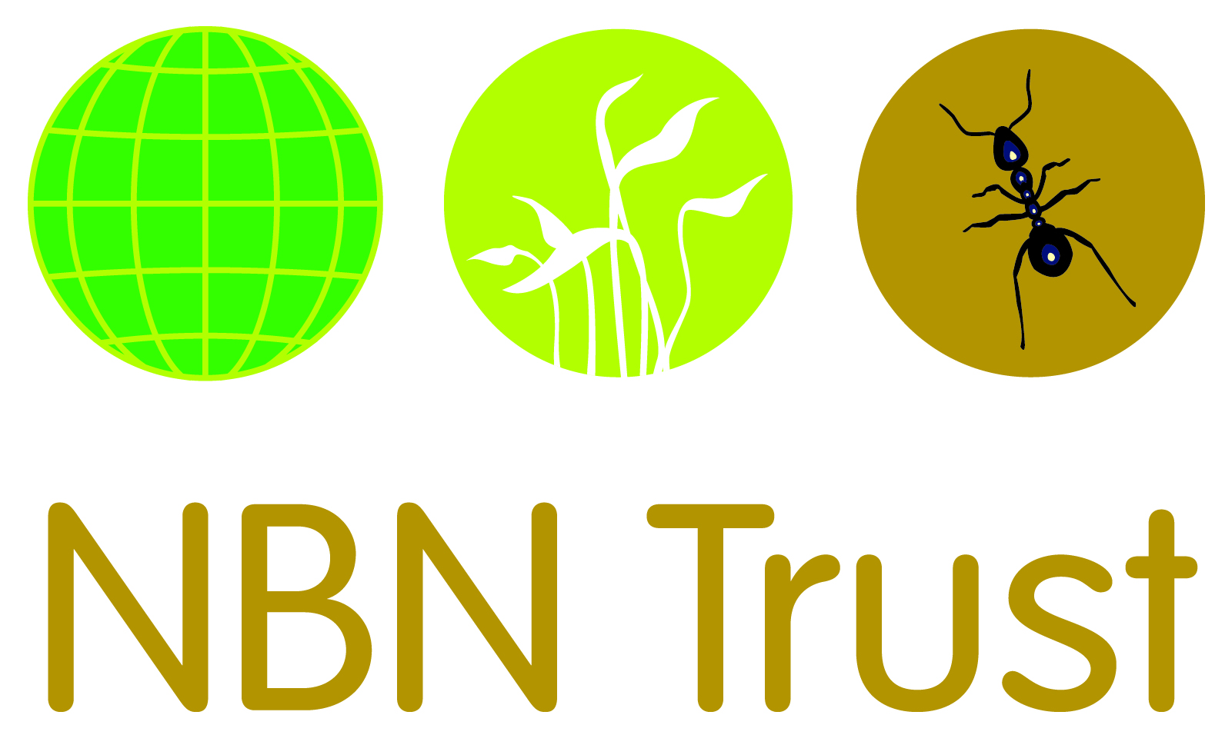

NBN Trust TRUSTEE RECRUITMENT PACK

ABOUT THE NBN

The National Biodiversity Network (NBN) is a membership organisation built on principles of collaboration and sharing biological information.
Biological data are recorded by many organisations and people, collected together using a range of systems, verified by experts, curated by a wide range of organisations and then aggregated and shared regionally primarily by Local Environmental Record Centres and nationally via the NBN Atlas which holds more than 217 million biological records.
The Network’s priority is to grow the national commitment to sharing biological data and information. Through this we will provide a comprehensive, unparalleled and authoritative understanding of our natural world and will use that knowledge effectively to educate and inform.
The NBN vision is that:
“Biological data collected and shared openly by the Network are central to the UK’s learning and understanding of its biodiversity and are critical to all decision-making about nature and the environment.”
To achieve that vision the Network must deliver improvements to the recording, collection, verification, curation, aggregation, analysis and use of biological data in the UK. (A new strategy is currently under development and will be launched in the coming year.

WHAT WE DO

In the UK there is an enormous amount of biodiversity information that has been gathered over the years by all sorts of organisations and individuals.
Most of these people are volunteers who organise themselves through many national and local societies and recording schemes. The UK government (through its conservation and environmental agencies), local government and non-government wildlife-related organisations all collect and use biodiversity data. One of the principal means of collation and interpretation of this data is the network of Local Environmental Records Centres and at the national level, the Biological Records Centre that collates and interprets data from national recording schemes.
This information is vital if we are to understand the distribution and abundance of species and habitats; without it, making informed decisions on how to protect the UK’s wildlife is much more difficult.

What happens to the information?
Information is held by many different organisations and the individuals who collect it in a variety of formats, from computer databases to handwritten record cards. This means that although a huge amount of information exists, it isn’t always easy to access. The National Biodiversity Network (NBN) idea could not be simpler: capture wildlife data once in a standard electronic form; integrate data from different sources; and use the internet to enable data to be used many times in different ways by as many people as possible.
One way in which the data is made available is through the NBN Atlas. The NBN Atlas quite simply acts as a “data warehouse” for biodiversity information, which can be quickly and easily accessed to understand the distribution of particular species in the UK. Individual records, covering plants, mammals, birds and invertebrates, are stored on the NBN Atlas and these can then be displayed on a map of the UK in a number of different ways.

ROLE DESCRIPTION

To be a Trustee of an organisation is an exciting and fulfilling role. The most effective Boards are ones which benefit from individuals from a diverse range of backgrounds, experiences and skill sets. The role of a Trustee is to ensure that the NBN Trust fulfils its duty and delivers on our vision, mission and values.

The statutory duties of a trustee are:

- To ensure the organisation complies with its governing document.
- To ensure that the organisation pursues its objectives as defined in its governing document. • To ensure the organisation applies its resources exclusively in pursuance of its objectives - the charity must not spend money on activities which are not included in its own objectives, no matter how 'charitable' and 'worthwhile' those activities are.
- To contribute actively to the Board of Trustees' role in giving firm strategic direction to the organisation, setting overall policy, defining goals and setting targets and evaluating performance against agreed targets.
- To safeguard the good name and values of the organisation.
- To ensure the effective and efficient administration of the organisation.
- To ensure the financial stability of the organisation.
- To protect and manage the property of the organisation and to ensure the proper investment of the organisation's funds.
- To appoint the Chief Executive Officer and monitor his or her performance.

In addition, with other trustees, to hold the charity “in trust” for current and future beneficiaries by:
- Ensuring that the charity has a clear vision, mission and strategic direction and is focused on achieving these.
- Being responsible for the performance of the charity and for its “corporate” behaviour; ensuring that the charity complies with all legal and regulatory requirements.
- Acting as guardians of the charity’s assets, both tangible and intangible, taking all due care over their security, deployment and proper application.
- Ensuring that the charity’s governance is of the highest possible standard.

As well as the various statutory duties, any trustee should make full use of any specific skills, knowledge or experience to help the board make good decisions.

The above list of duties is indicative only and not exhaustive. The Trustee will be expected to perform all such additional duties as are reasonably commensurate with the role.

PERSON SPECIFICATION

The Board of Trustees are jointly and severally responsible for the overall governance and strategic direction of the charity, its financial health, the probity of its activities and developing the organisations aims, objectives and goals.

All trustees, should also be aware of, and understand, their individual and collective responsibilities, and should not be overly reliant on one or more individual trustees in any particular aspect of the governance of the charity.

We are seeking talented and committed individuals to enhance and extend the range of skills represented on our board.

Personal qualities
- Commitment to the ethos and values of the NBN Trust
- Commitment to equal opportunities and the promotion of diversity
- Independence of thought and judgement
- Ability to work as part of a team
- Willingness to devote time, enthusiasm and effort to the duties and responsibilities of a trustee

Aptitude and skills
- An understanding and acceptance of the legal duties, responsibilities and liabilities of trusteeship
- Ability to evaluate and interpret information
- Ability to play a strategic role to successfully effect change and meet objectives of the NBN Trust
- Eagerness to reflect and learn

Knowledge and experience
Specific professional knowledge, experience and skills in at least one of the following areas:
- Fundraising
- IT systems development/ hosting
- Data management
- Finance/accountancy
- Professional expertise in the collection, curation and use of biodiversity data
- Commercial experience in ecological / environmental sector

Other requirements
- Willingness to attend board meetings and other meetings as required. Board meetings are held at the Natural History Museum in London four times a year, although they are currently being held online and some may continue in that way in future
- Willingness to undertake other trustee responsibilities as required
- Willingness to undertake training where required and participate in the evaluation of the board’s work

COMMITMENT
This document provides a summary of the commitments expected of trustees of the NBN Trust and the commitments the NBN Trust gives to its trustees.
Commitment of trustees to the NBN
- To act solely in the interests of the charity
- To declare all actual or potential conflicts of interest
- To act collectively
- To respect confidentiality
- To make available skills and experience to the NBN Trust
- To regularly attend board and committee meetings (if appropriate) having fully prepared for these meetings
- To gain a better understanding of the NBN Trust by attending at least one event a year
- To support the chief executive and the management of the NBN Trust
- Where appropriate, to challenge current thinking, the method of governance and management of the NBN Trust, but always constructively and acting in the best interest of the charity
- To work in partnership with the staff to achieve the mission of the NBN Trust, understanding and respecting the different but complementary roles of trustees and staff
- To regularly and collectively reflect on how the board fulfils its responsibilities as trustees of the charity and how the board brings added value to the achievements of the NBN Trust’s objectives

Commitments of the NBN Trust to trustees
- To provide the board with high quality information in order to allow the board to govern well
- To provide the board with timely advice ensuring that the external professional advisors are available as and when needed
- To work in partnership with the board to ensure that the board fulfils its statutory and legal responsibilities
- To invest time, money and other resources in order to help develop good governance
- To ensure that a trustees’ handbook is available and regularly updated
- To work in partnership with the honorary officers and nominations committee to ensure that new trustees receive induction and support, and that appropriate briefings and/or training are available to all trustees
- To provide honorary officers and trustees with the necessary administrative and other support that they need to govern well
- To reimburse trustees’ reasonable expenses incurred in the course of their duties as trustees

HOW TO APPLY

If you are interested in joining the board of the NBN Trust and you have skills you think could help steer the charity, please supply the following:

- A comprehensive CV outlining your key achievements in previous and current roles
- A covering letter detailing why you are interested in the role and why you believe your skills would support the NBN Trust
- Details of two referees (who will not be contacted without your prior consent)

If you would like a confidential conversation with our Chair (Neil Hodges) about the role (before applying) please email n.hodges@nbn.org.uk to set up a time.

The closing date for applications is Wednesday 3rd March 2021 at 12 noon

Interviews are to take place online on Friday 19th March 2021

