False Blister Beetles (Oedemera spp.) in Scotland
The general shape of all four Oedemera species is very similar. They are all slim with tapering elytra that have longitudinal ridges and could at first glance be mistaken for longhorn beetles. There are two species of Oedemera that occur in Scotland and another two that might be found here. The relative distributions of the two Scottish species are not well known and more records are needed in order to clarify the situation.
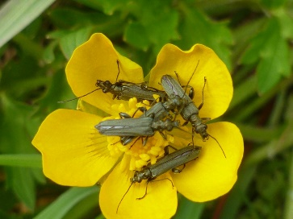
Oedemera virescens: 7-9mm. A slim, dull ‘sage green’ beetle that can be abundant and is usually found in flowers, often buttercups. The males (see photo) have slightly swollen femora while the femora of the females are slim.
This appears to be the more widely distributed species with a lot of records from south west Scotland. Until relatively recently it was a Red Data Book species more or less restricted to the north east of England but it appears to have expanded its range although it is still classed as Nationally Rare. From a few records in Ayrshire in the early 21st century it seems now to have spread north. There is a 2018 record from Skye that could be this species.
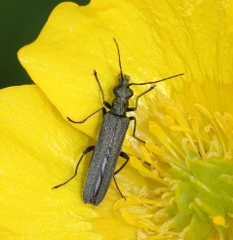
Oedemera lurida: 6-8mm. Very similar in appearance to O. virescens and has similar habits. While on average it is slightly smaller this is not a good distinguishing characteristic. Both sexes have slim femora so the two species are easily confused, especially as they share similar pollen feeding habits. A guide to separating the two species is given on the next page.
Although common in England there are very few Scottish records. However it is possible that it is more widespread than currently realised and more records are needed.
The focus of this request is very much on O. virescens and O. lurida. Any records should where possible be accompanied by either a specimen or a good photo (especially showing the hind legs) plus date, grid reference and location.

These are the two possibly Scottish species. Any records would be welcome, again accompanied by full details, photos etc.
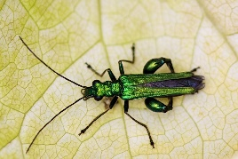
Oedemera nobilis (The Swollen-thighed beetle): 8-11mm. O. nobilis is larger and is a much brighter green with slimmer elytra that are separate at the apex. It is common and widespread in England but has been apparently not been recorded in Scotland. The males have grossly swollen femora and while the females’ femora are slim their colour and larger size should distinguish them. Another pollen feeder, it is likely that if it is found in Scotland it is restricted to the very south.
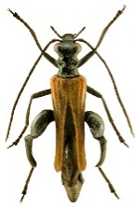
Oedemera femoralis: 13-20mm. This is much the largest member of the genus and is brown rather than green. It is also nocturnal and is found on trees such as willow. It has been recorded in Scotland but it seems likely that any new records will be in the very south.

