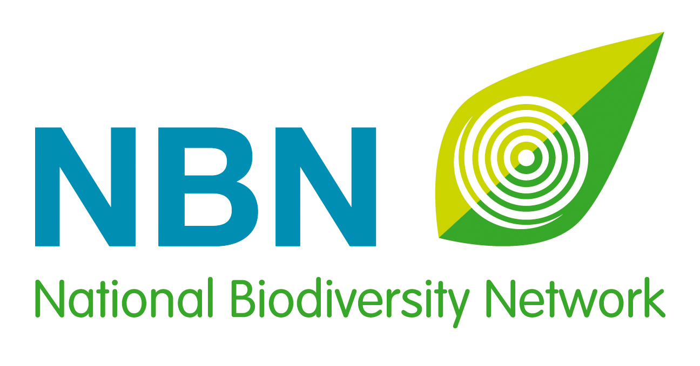
NBN Awards for Wildlife Recording 2019 - Social Media Kit

Overview
Nominations open: 8 May 2019.
Nominations close: 11 August 2019.
Shortlist announced: 1 October 2019.
Winners announced: 13 November 2019, at a ceremony that is part of the National Biodiversity Network’s annual conference, in Nottingham.

Main hashtags: #NBNawards19, #WildlifeRecording, #Wildlife, #Conservation, #LoveWildlife
#Nature, #Biodiversity, #YearofGreenAction, #Nature, #iwill4nature

Main Twitter handles: @NBNTrust, @NBNAtlas, @iRecordWildlife, @iSpotnature, @inaturalist
Supporting Twitter handles: @_NFBR, @___BRC___, @opticronuk, @FieldStudiesC,
@NatPhotoLtd, @WmCollinsBooks, @britwildlife, @nhbsNews

Website: bit.ly/NBNawards19
Contacts: m.henshall@nbn.org.uk and p.choudhury@nbn.org.uk

About the NBN Awards for Wildlife Recording

Developed in 2015 by the National Biodiversity Network Trust, the National Forum for Biological Recording and the Biological Records Centre, these annual Awards celebrate the individuals, the newcomers and the groups of people or organisations that are making outstanding contributions to wildlife recording and improving our understanding of the natural world in the UK.

Suggested Messages by Platform

1. Twitter

(Timing: From 8 May to 4 June 2019)

Nominations are open for #NBNawards19 Which exceptional #Wildlife recorder or group will you nominate? bit.ly/NBNawards19 Thanks to Award sponsors @opticronuk, Mrs. Ceri Leigh, @FieldStudiesC, @NatPhotoLtd, @WmCollinsBooks, @britwildlife and @nhbsNews

#WildlifeRecording is essential for UK #Conservation. Who are your unsung heroes? Nominate them for #NBNawards19! bit.ly/NBNawards19 [***Please tag @NBNTrust, @iRecordWildlife, @iSpotnature, @inaturalist, @opticronuk, @FieldStudiesC, @NatPhotoLtd, @WmCollinsBooks, @britwildlife and @nhbsNews with any photo you use to illustrate this tweet***]

30,000 UK #WildlifeRecords are made every day! Who will you nominate for #NBNawards19? bit.ly/NBNawards19 [***Please tag @NBNTrust, @iRecordWildlife, @iSpotnature, @inaturalist, @opticronuk, @FieldStudiesC, @NatPhotoLtd, @WmCollinsBooks, @britwildlife and @nhbsNews with any photo you use to illustrate this tweet***]

@NBNAtlas holds over 222 million records. Is your favourite #Wildlife recorder sharing their data? Nominate them for #NBNawards19 bit.ly/NBNawards19 [***Please tag @NBNTrust, @iRecordWildlife, @iSpotnature, @inaturalist, @opticronuk, @FieldStudiesC, @NatPhotoLtd, @WmCollinsBooks, @britwildlife and @nhbsNews with any photo you use to illustrate this tweet***]

(Timing: 5 June - 16 July 2019)

Help recognise UK #Wildlife recorders, nominate your #NBNawards19 winner now! bit.ly/NBNawards19 [***Please tag @NBNTrust, @iRecordWildlife, @iSpotnature, @inaturalist, @opticronuk, @FieldStudiesC, @NatPhotoLtd, @WmCollinsBooks, @britwildlife and @nhbsNews with any photo you use to illustrate this tweet***]

We need to encourage young #Wildlife recorders, nominate your Young Person’s Award winner now! #NBNawards19 #iwill4nature bit.ly/NBNawards19 [***Please tag @NBNTrust, @iRecordWildlife, @iSpotnature, @inaturalist, @opticronuk, @FieldStudiesC, @NatPhotoLtd, @WmCollinsBooks, @britwildlife and @nhbsNews with any photo you use to illustrate this tweet***]

Is someone new to #WildlifeRecording making their mark? Nominate them for the NBN Newcomer Award! #NBNawards19 #YearofGreenAction bit.ly/NBNawards19 [***Please tag @NBNTrust, @iRecordWildlife, @iSpotnature, @inaturalist, @opticronuk, @FieldStudiesC, @NatPhotoLtd, @WmCollinsBooks, @britwildlife and @nhbsNews with any photo you use to illustrate this tweet***]

Who deserves recognition for years of #WildlifeRecording? Nominate them for #NBNawards19! bit.ly/NBNawards19 [***Please tag @NBNTrust, @iRecordWildlife, @iSpotnature, @inaturalist, @opticronuk, @FieldStudiesC, @NatPhotoLtd, @WmCollinsBooks, @britwildlife and @nhbsNews with any photo you use to illustrate this tweet***]

Is there a local or national group of #Wildlife recorders worthy of the NBN Group Award? Nominate them now! #NBNawards19 #Nature #Conservation #Biodiversity bit.ly/NBNawards19 [***Please tag @NBNTrust, @iRecordWildlife, @iSpotnature, @inaturalist, @opticronuk, @FieldStudiesC, @NatPhotoLtd, @WmCollinsBooks, @britwildlife and @nhbsNews with any photo you use to illustrate this tweet***]

#NBNAwards19 shortlist will be announced on 1 October – make sure you’ve nominated your favourite #Wildlife recorders, so they don’t miss out! #iwill4nature #YearofGreenAction bit.ly/NBNawards19 [***Please tag @NBNTrust, @iRecordWildlife, @iSpotnature, @inaturalist, @opticronuk, @FieldStudiesC, @NatPhotoLtd, @WmCollinsBooks, @britwildlife and @nhbsNews with any photo you use to illustrate this tweet***]

(Timing: 17 July to 11 August 2019)

Hurry! Time is running out!! Nominate your favourite #Wildlife recorders for #NBNAwards19 before 11 August… #iwill4nature #YearofGreenAction bit.ly/NBNawards19 [***Please tag @NBNTrust, @iRecordWildlife, @iSpotnature, @inaturalist, @opticronuk, @FieldStudiesC, @NatPhotoLtd, @WmCollinsBooks, @britwildlife and @nhbsNews with any photo you use to illustrate this tweet***]

2. Facebook and LinkedIn

(Timing: From 8 May to 4 June 2019)

Nominations have opened for the NBN Awards for Wildlife Recording 2019!

Developed in 2015 by the National Biodiversity Network Trust, the National Forum for Biological Recording and the Biological Records Centre, these annual Awards celebrate the individuals, the newcomers and the groups of people or organisations that are making outstanding contributions to Wildlife recording and improving our understanding of the natural world in the UK.

There are five categories of awards:
- NBN Award for wildlife recording - terrestrial (open to individuals 21 years +)
- NBN Award for wildlife recording - marine (open to individuals 21 years +)
- NBN Group Award (no age restrictions)
- NBN Young Person’s Award (open to individuals aged 11-20)
- NBN Newcomer Award (open to individuals 21 years +)

All too often the painstaking work that individual and groups of Wildlife recorders undertake is not publicly recognised. So help us put that right, and nominate your unsung heroes!

Nominating someone couldn’t be simpler, just fill in our short form explaining how your nominee is making an exceptional contribution in the world of UK wildlife recording. You can even nominate yourself!

Nominations close on 11 August, so please don’t leave it too late…. bit.ly/NBNawards19

The five short-listed nominees from each award category will be announced on 1 October, giving us the opportunity to recognise their achievements before announcing the winners at a special ceremony on 13 November, as part of the National Biodiversity Network's annual conference in Nottingham.

(Timing: From 5 to 18 June 2019)

Which young person will you nominate for the NBN Awards for Wildlife Recording 2019?

There are so many young people getting involved with wildlife, taking part in bio-blitzes, and joining local recording groups – they deserve recognition! Whose contribution are you going to celebrate and publicise?

Nominating a young person couldn’t be simpler, just fill in the short form explaining how your nominee is making an exceptional contribution in the world of wildlife recording. You can even nominate yourself!

Nominations close on 11 August, so please don’t leave it too late….. bit.ly/NBNawards19

The five short-listed nominees from each award category will be announced on 1 October, giving us the opportunity to recognise their achievements before announcing the winners at a special ceremony on 13 November, as part of the National Biodiversity Network's annual conference in Nottingham.

(Timing: 19 June - 2 July 2019)

Which exceptional wildlife recorders will you nominate for the NBN Awards for Wildlife Recording 2019?

All too often the painstaking work that an individual recorder has undertaken, over many years, is not publicly recognised. So help us put that right, and nominate your unsung heroes!

There are three categories of awards for individuals over the age of 21:
- Terrestrial
- Marine
- Newcomer

Nominating someone couldn’t be simpler, just fill in the short form explaining how your nominee is making an exceptional contribution in the world of wildlife recording. You can even nominate yourself!

Nominations close on 11 August, so please don’t leave it too late….. bit.ly/NBNawards19

The five short-listed nominees from each award category will be announced on 1 October, giving us the opportunity to recognise their achievements before announcing the winners at a special ceremony on 13 November, as part of the National Biodiversity Network's annual conference in Nottingham.

(Timing: 3 to 16 July 2019)

Which wildlife group will you nominate for the NBN Awards for Wildlife Recording 2019?

There is so much wonderful work being carried out by local and national wildlife groups in the UK – they deserve recognition! Whose contribution are you going to celebrate and publicise?

Nominating a wildlife group couldn’t be simpler, just fill in the short form explaining how your chosen group is making an exceptional contribution in the world of wildlife recording. You can even nominate your own group!

Nominations close on 11 August, so please don’t leave it too late….. bit.ly/NBNawards19

The five short-listed nominees from each award category will be announced on 1 October, giving us the opportunity to recognise their achievements before announcing the winners at a special ceremony on 13 November, as part of the National Biodiversity Network's annual conference in Nottingham.

(Timing: 17 to 30 July 2019)

Which newcomer will you nominate for the NBN Awards for Wildlife Recording 2019?

Is there someone, relatively new to Wildlife recording, who is already making their mark? Or inspiring others with their infectious enthusiasm?

Nominating someone couldn’t be simpler, just fill in the short form explaining how your nominee is worthy of the NBN Newcomer Award. You can even nominate yourself!

Nominations close on 11 August, so please don’t leave it too late….. bit.ly/NBNawards19

The five short-listed nominees from each award category will be announced on 1 October, giving us the opportunity to recognise their achievements before announcing the winners at a special ceremony on 13 November, as part of the National Biodiversity Network's annual conference in Nottingham.

(Timing: From 31 July to 11 August 2019)

Time is running out to nominate your unsung wildlife recording heroes!

Whose exceptional contributions do you want to recognise and publicise? Hurry and nominate them for the NBN Awards for Wildlife Recording 2019 now!

There are five categories of awards this year:
- NBN Award for wildlife recording - terrestrial (open to individuals 21 years +)
- NBN Award for wildlife recording - marine (open to individuals 21 years +)
- NBN Group Award (no age restrictions)
- NBN Young Person’s Award (open to individuals aged 11-20)
- NBN Newcomer Award (open to individuals 21 years +)

Nominating someone couldn’t be simpler, just fill in a short form explaining how your nominee is making an exceptional contribution in the world of UK Wildlife recording. You can even nominate yourself.

Nominations close on 11 August, so please don’t delay…..! bit.ly/NBNawards19

The five short-listed nominees from each award category will be announced on 1 October, giving us the opportunity to recognise their achievements before announcing the winners at a special ceremony on 13 November, as part of the National Biodiversity Network's annual conference in Nottingham.

