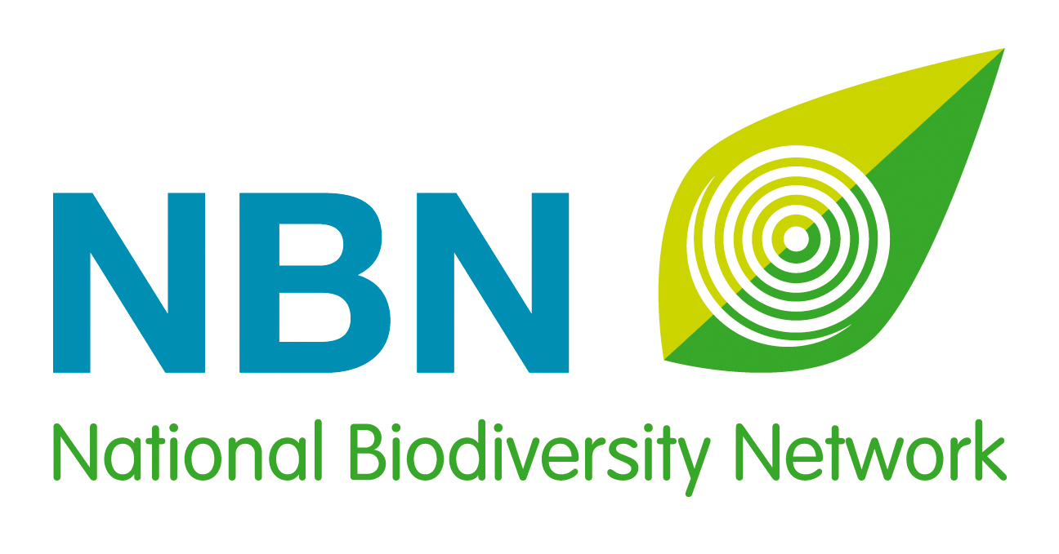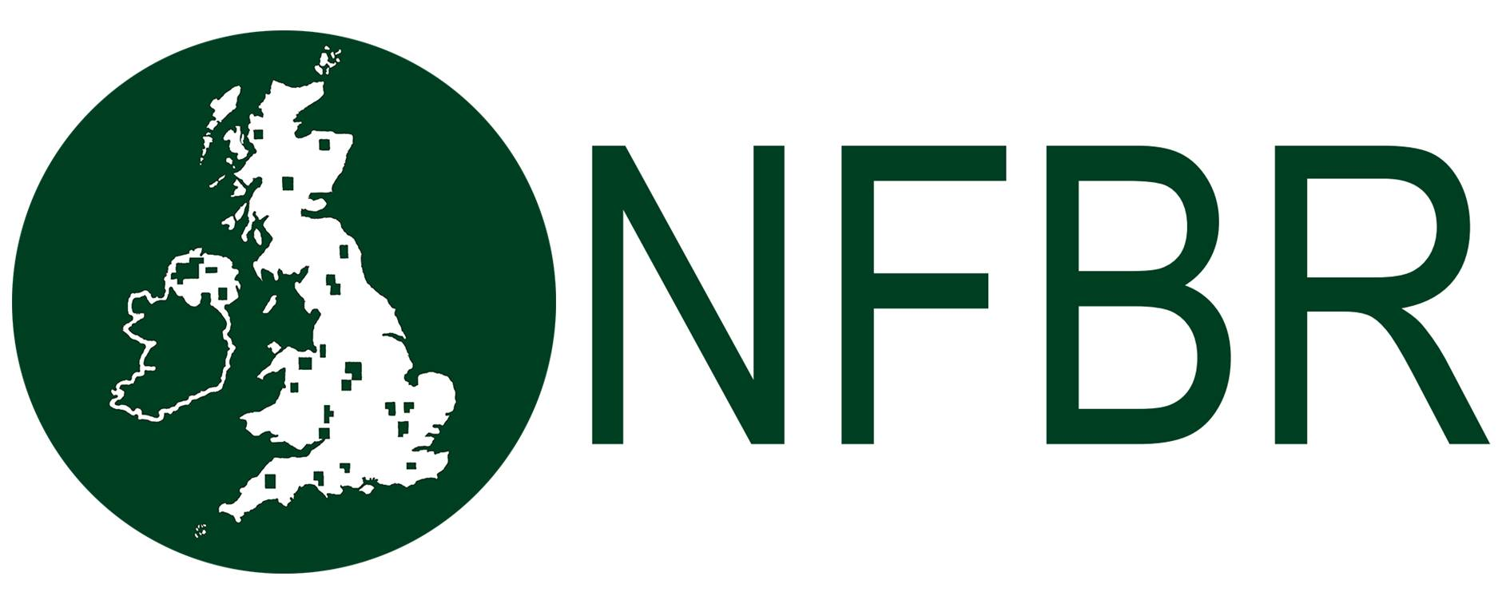

UK Awards for Biological Recording and Information Sharing 2018
Social Media Kit

Overview
Nominations open: 6 June 2018.
Nominations close: 31 July 2018.
Shortlist announced: 27 September 2018.
Winners announced: At a ceremony that is part of the National Biodiversity Network’s annual conference, on 21 November 2018.

Theme: Celebrate the contribution of your unsung heroes!
Main hashtags: #NBNAwards18, #UnsungHero, #YouthAwards, #AdultAwards, #GroupAward, #NewcomerAward, #BiologicalRecording, #BiologicalRecorders

Main Twitter handles: @NBNTrust, @NFBR, @__BRC__
Supporting Twitter handles: @opticronuk, @ParamoClothing, @FieldStudiesC, @NatPhotoLtd,
@GilbertWhites
Website: bit.ly/NBNawards18
Contacts: m.henshall@nbn.org.uk and p.choudhury@nbn.org.uk

About the UK Awards for Biological Recording and Information Sharing

Developed in 2015 by the National Biodiversity Network Trust, the National Forum for Biological Recording and the Biological Records Centre, these annual Awards celebrate the individuals, the newcomers and the groups of people or organisations that are making outstanding contributions to biological recording and improving our understanding of the natural world in the UK.

Suggested Messages by Platform

1. Twitter

(Timing: From 6-27 June 2018)

Nominations are open for #NBNAwards18 Who is your #UnsungHero in the #BiologicalRecording world? bit.ly/NBNawards18 Award Partners: @NBNTrust, @_NFBR and @__BRC__ Thanks to sponsors @opticronuk, @ParamoClothing, @FieldStudiesC and @NatPhotoLtd and supporter @GilbertWhites

#BiologicalRecording is essential for UK conservation. Who is your #UnsungHero? #NBNawards18 bit.ly/NBNawards18 [***Please tag @NBNTrust, @_NFBR, @__BRC__ @opticronuk, @ParamoClothing, @FieldStudiesC, @NatPhotoLtd and @GilbertWhites with any photo you use to illustrate this tweet***]

30,000 UK #BiologicalRecords made every day! Who will you nominate? #NBNawards18 bit.ly/NBNawards18 [***Please tag @NBNTrust, @_NFBR, @__BRC__ @opticronuk, @ParamoClothing, @FieldStudiesC, @NatPhotoLtd and @GilbertWhites with any photo you use to illustrate this tweet***]

@NBNAtlas holds over 219 million records. Is your #UnsungHero contributing UK wildlife data? #NBNawards18 bit.ly/NBNawards18 [***Please tag @NBNTrust, @_NFBR, @__BRC__ @opticronuk, @ParamoClothing, @FieldStudiesC, @NatPhotoLtd and @GilbertWhites with any photo you use to illustrate this tweet***]

(Timing: 28 June - 15 July 2018)

Help recognise UK #BiologicalRecorders, nominate your #NBNAwards18 winner now! bit.ly/NBNawards18 [***Please tag @NBNTrust, @_NFBR, @__BRC__ @opticronuk, @ParamoClothing, @FieldStudiesC, @NatPhotoLtd and @GilbertWhites with any photo you use to illustrate this tweet***]

We need to encourage young #BiologicalRecorders, nominate your #YouthAwards winner now! #NBNawards18 bit.ly/NBNawards18 [***Please tag @NBNTrust, @_NFBR, @__BRC__ @opticronuk, @ParamoClothing, @FieldStudiesC, @NatPhotoLtd and @GilbertWhites with any photo you use to illustrate this tweet***]

Is someone new to #BiologicalRecording making their mark? Nominate them for a #NewcomerAward! #NBNawards18 bit.ly/NBNawards18 [***Please tag @NBNTrust, @_NFBR, @__BRC__ @opticronuk, @ParamoClothing, @FieldStudiesC, @NatPhotoLtd and @GilbertWhites with any photo you use to illustrate this tweet***]

Who deserves recognition for years of #BiologicalRecording? Nominate them for #AdultAwards #NBNawards18 bit.ly/NBNawards18 [***Please tag @NBNTrust, @_NFBR, @__BRC__ @opticronuk, @ParamoClothing, @FieldStudiesC, @NatPhotoLtd and @GilbertWhites with any photo you use to illustrate this tweet***]

Is there a local or national group of #BiologicalRecorders worthy of a #GroupAward? Nominate now! #NBNawards18 bit.ly/NBNawards18 [***Please tag @NBNTrust, @_NFBR, @__BRC__ @opticronuk, @ParamoClothing, @FieldStudiesC, @NatPhotoLtd and @GilbertWhites with any photo you use to illustrate this tweet***]

#NBNAwards18 shortlist will be announced on 27 Sept – don’t let your #UnsungHero miss out! bit.ly/NBNawards18 [***Please tag @NBNTrust, @_NFBR, @__BRC__ @opticronuk, @ParamoClothing, @FieldStudiesC, @NatPhotoLtd and @GilbertWhites with any photo you use to illustrate this tweet***]

(Timing: 16-31 July 2018)

Time is running out! Nominate your #UnsungHero for #NBNAwards18 before 31 July… bit.ly/NBNawards18 [***Please tag @NBNTrust, @_NFBR, @__BRC__ @opticronuk, @ParamoClothing, @FieldStudiesC, @NatPhotoLtd and @GilbertWhites with any photo you use to illustrate this tweet***]

2. Facebook and LinkedIn

(Timing: From 6-17 June 2018)

Nominations have opened for the 2018 UK Awards for Biological Recording and Information Sharing!

Developed in 2015 by the National Biodiversity Network Trust, the National Forum for Biological Recording and the Biological Records Centre, these annual Awards celebrate the individuals, the newcomers and the groups of people or organisations that are making outstanding contributions to biological recording and improving our understanding of the natural world in the UK.

There are six categories of awards:
- Gilbert White Youth Award for recording terrestrial and freshwater wildlife
- Gilbert White Adult Award for recording terrestrial and freshwater wildlife
- David Robertson Youth Award for recording marine and coastal wildlife
- David Robertson Adult Award for recording marine and coastal wildlife
- Lynne Farrell Group Award for recording wildlife
- Adult Newcomer Award for recording wildlife

All too often the painstaking work that individual and groups of biological recorders undertake is not publicly recognised. So help us put that right, and nominate your unsung hero!

Nominating someone couldn’t be simpler, just fill in our short form explaining how your nominee is making an exceptional contribution in the world of UK biological recording. You can even nominate yourself!

Nominations close on 31 July, so please don’t leave it too late…. bit.ly/NBNawards18

The five short-listed nominees from each award category will be announced on 27 September, giving us the opportunity to recognise their achievements before announcing the winners at a special ceremony on 21 November, as part of the National Biodiversity Network's annual conference in Nottingham.

(Timing: From 18-24 June 2018)

Which young person will you nominate for the 2018 UK Awards for Biological Recording and Information Sharing?

There are so many young people getting involved with wildlife, taking part in bio-blitzes, and joining local recording groups – they deserve recognition! Whose contribution are you going to celebrate and publicise?

There are two categories of awards for under-18 year olds:
- Gilbert White Youth Award for recording terrestrial and freshwater wildlife
- David Robertson Youth Award for recording marine and coastal wildlife

Nominating a young person couldn’t be simpler, just fill in the short form explaining how your nominee is making an exceptional contribution in the world of biological recording. You can even nominate yourself!

Nominations close on 31 July, so please don’t leave it too late….. bit.ly/NBNawards18

The five short-listed nominees from each award category will be announced on 27 September, giving us the opportunity to recognise their achievements before announcing the winners at a special ceremony on 21 November, as part of the National Biodiversity Network's annual conference in Nottingham.

(Timing: 25 June - 1 July 2018)

Which exceptional biological recorder will you nominate for the 2018 UK Awards for Biological Recording and Information Sharing?

All too often the painstaking work that an individual recorder has undertaken, over many years, is not publicly recognised. So help us put that right, and nominate your unsung hero!

There are two categories of awards for adults:
- Gilbert White Adult Award for recording terrestrial and freshwater wildlife
- David Robertson Adult Award for recording marine and coastal wildlife

Nominating someone couldn’t be simpler, just fill in the short form explaining how your nominee is making an exceptional contribution in the world of biological recording. You can even nominate yourself!

Nominations close on 31 July, so please don’t leave it too late….. bit.ly/NBNawards18

The five short-listed nominees from each award category will be announced on 27 September, giving us the opportunity to recognise their achievements before announcing the winners at a special ceremony on 21 November, as part of the National Biodiversity Network's annual conference in Nottingham.

(Timing: 2-8 July 2018)

Which wildlife group will you nominate for the 2018 UK Awards for Biological Recording and Information Sharing?

There is so much wonderful work being carried out by local and national wildlife groups in the UK – they deserve recognition! Whose contribution are you going to celebrate and publicise?

Nominate your favourite wildlife organisation for the:
- Lynne Farrell Group Award for recording wildlife

Nominating a wildlife group couldn’t be simpler, just fill in the short form explaining how your chosen group is making an exceptional contribution in the world of biological recording. You can even nominate your own group!

Nominations close on 31 July, so please don’t leave it too late….. bit.ly/NBNawards18

The five short-listed nominees from each award category will be announced on 27 September, giving us the opportunity to recognise their achievements before announcing the winners at a special ceremony on 21 November, as part of the National Biodiversity Network's annual conference in Nottingham.

(Timing: 9-15 July 2018)

Which newcomer will you nominate for the 2018 UK Awards for Biological Recording and Information Sharing?

Is there someone, relatively new to biological recording, who is already making their mark? Or inspiring others with their infectious enthusiasm?

Nominate an outstanding newcomer for the:
- Adult Newcomer Award for recording wildlife

Nominating someone couldn’t be simpler, just fill in the short form explaining how your nominee is worthy of the Adult Newcomer Award. You can even nominate yourself!

Nominations close on 31 July, so please don’t leave it too late….. bit.ly/NBNawards18

The five short-listed nominees from each award category will be announced on 27 September, giving us the opportunity to recognise their achievements before announcing the winners at a special ceremony on 21 November, as part of the National Biodiversity Network's annual conference in Nottingham.

(Timing: From 16-31 July 2018)

Time is running out to nominate your unsung biological recording heroes!

Whose exceptional contributions do you want to recognise and publicise? Hurry and nominate them for the 2018 UK Awards for Biological Recording and Information Sharing now.

There are six categories of awards this year:
- Gilbert White Youth Award for recording terrestrial and freshwater wildlife
- Gilbert White Adult Award for recording terrestrial and freshwater wildlife
- David Robertson Youth Award for recording marine and coastal wildlife
- David Robertson Adult Award for recording marine and coastal wildlife
- Lynne Farrell Group Award for recording wildlife
- Adult Newcomer Award for recording wildlife

Nominating someone couldn’t be simpler, just fill in a short form explaining how your nominee is making an exceptional contribution in the world of UK biological recording. You can even nominate yourself.

Nominations close on 31 July, so please don’t delay…..! bit.ly/NBNawards18

The five short-listed nominees from each award category will be announced on 27 September, giving us the opportunity to recognise their achievements before announcing the winners at a special ceremony on 21 November, as part of the National Biodiversity Network's annual conference in Nottingham.

