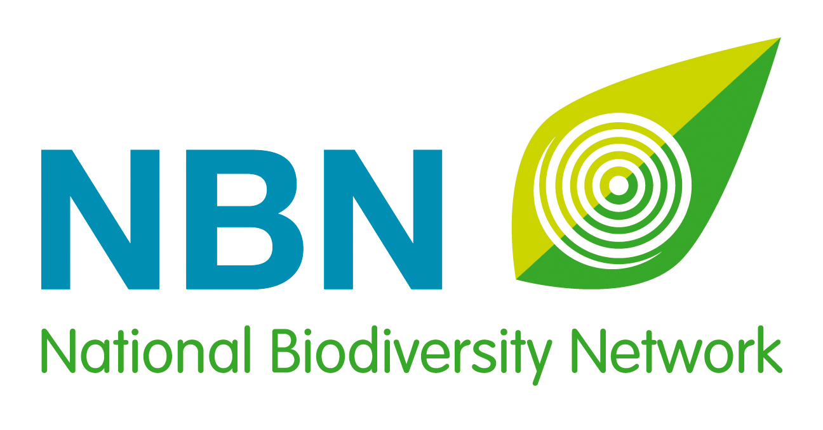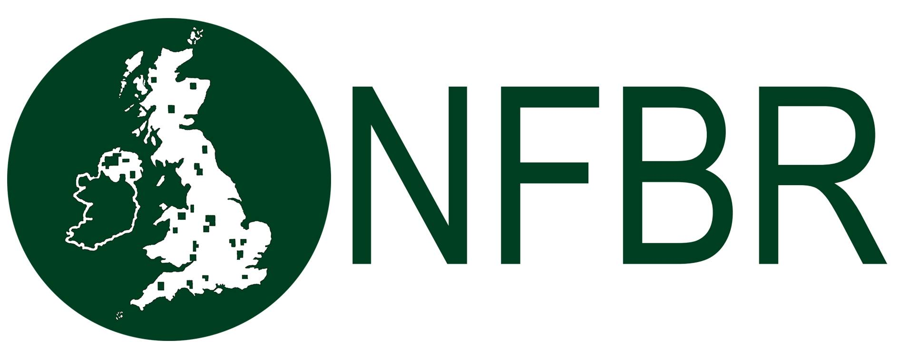

UK Awards for Biological Recording and Information Sharing 2017
Social Media Kit
Overview
Nominations open: 3 May 2017.
Nominations close: 31 July 2017.
Shortlist announced: 29 September 2017.
Winners announced: At a ceremony that is part of the National Biodiversity Network’s annual conference, in November 2017.

Theme: recognise your unsung hero in biological recording
Main hashtags: #NBNAwards17, #UnsungHero, #YouthAwards, #AdultAwards, #GroupAward, #NewcomerAward, #BiologicalRecording, #BiologicalRecorders

Main Twitter handles: @NBNTrust, @NFBR, @__BRC__
Supporting Twitter handles: @opticronuk, @GilbertWhites, @FieldStudiesC, @ParamoClothing
Website: bit.ly/NBNawards
Contacts: m.henshall@nbn.org.uk and p.choudhury@nbn.org.uk

About the UK Awards for Biological Recording and Information Sharing

Developed in 2015 by the National Biodiversity Network, the National Forum for Biological Recording and the Biological Records Centre, these annual Awards celebrate the individuals, the newcomers and the groups of people or organisations that are making outstanding contributions to biological recording and improving our understanding of the natural world in the UK.

Suggested Messages by Platform

Twitter
(Timing: From 1 May-31 July 2017)

Awareness Raising:

Nominations are open for #NBNAwards17 Who is your #UnsungHero? bit.ly/NBNawards

#BiologicalRecording is essential for UK conservation. Who is your #UnsungHero? #NBNAwards17 bit.ly/NBNawards

30,000 UK #BiologicalRecords made every day! Who will you nominate? #NBNAwards17 bit.ly/NBNawards

@NBNAtlas holds over 200 million records. Is your #UnsungHero contributing to the UK data? #NBNAwards17 bit.ly/NBNawards

Calls to Action:

Help recognise UK #BiologicalRecorders, nominate your #NBNAwards17 winner now! bit.ly/NBNawards

We need to encourage young #BiologicalRecorders, nominate your #YouthAwards winner now! #NBNAwards17 bit.ly/NBNawards

Is someone new to #BiologicalRecording making their mark? Nominate them for a #NewcomerAward! #NBNAwards17 bit.ly/NBNawards

Who deserves recognition for years of #BiologicalRecording? Nominate them for #AdultAwards #NBNAwards17 bit.ly/NBNawards

Is there a local or national group of #BiologicalRecorders worthy of a #GroupAward? #NBNAwards17 Nominate now! bit.ly/NBNawards

Time is running out! Nominate your #UnsungHero for #NBNAwards17 before 31 July… bit.ly/NBNawards

#NBNAwards17 shortlist will be announced on 29 Sept – don’t let your #UnsungHero miss out! bit.ly/NBNawards

Facebook and LinkedIn

(Timing: From 1-14 May)

Nominations have opened for the 2017 UK Awards for Biological Recording and Information Sharing!

Developed in 2015 by the National Biodiversity Network, the National Forum for Biological Recording and the Biological Records Centre, these annual Awards celebrate the individuals, the newcomers and the groups of people or organisations that are making outstanding contributions to biological recording and improving our understanding of the natural world in the UK.

There are six categories of awards this year:
- Gilbert White Youth Award for terrestrial and freshwater wildlife
- Gilbert White Adult Award for terrestrial and freshwater wildlife
- David Robertson Youth Award for marine and coastal wildlife
- David Robertson Adult Award for marine and coastal wildlife
- Lynne Farrell Group Award for wildlife recording
- Adult Newcomer Award

All too often the painstaking work that individual and groups of biological recorders undertake is not publically recognised. So help us put that right, and nominate your unsung hero!

Nominating someone couldn’t be simpler, just fill in our short form explaining how your nominee is making an exceptional contribution in the world of UK biological recording. You can even nominate yourself!

Nominations close on 31 July, so please don’t leave it too late….. bit.ly/NBNawards

This year, the five short-listed nominees from each award category will be announced on 29 September, giving us the opportunity to recognise the achievements of more biological recorders than in previous years.

The winners will be announced at a special ceremony that is part of the National Biodiversity Network's annual conference in November.

(Timing: From 15 May – 28 May)

Which young person will you nominate for the 2017 UK Awards for Biological Recording and Information Sharing?

There are so many young people getting involved with wildlife, taking part in bio-blitzes, and joining local recording groups, whose contribution are you going to celebrate and publicise?

There are two categories of awards for under-18 year olds:
- Gilbert White Youth Award for terrestrial and freshwater wildlife
- David Robertson Youth Award for marine and coastal wildlife

Nominating a young person couldn’t be simpler, just fill in the short form explaining how your nominee is making an exceptional contribution in the world of biological recording. You can even nominate yourself!

Nominations close on 31 July, so please don’t leave it too late….. bit.ly/NBNawards

This year, the five short-listed nominees from each award category will be announced on 29 September, giving us the opportunity to recognise the achievements of more biological recorders than in previous years.

The winners will be announced at a special ceremony that is part of the National Biodiversity Network's annual conference in November.

(Timing: 29 May-11 June)

Which exceptional biological recorder will you nominate for the 2017 UK Awards for Biological Recording and Information Sharing?

All too often the painstaking work that an individual recorder has undertaken, over many years, is not publically recognised. So help us put that right, and nominate your unsung hero!

There are two categories of awards for adults:
- Gilbert White Adult Award for terrestrial and freshwater wildlife
- David Robertson Adult Award for marine and coastal wildlife

Nominating someone couldn’t be simpler, just fill in the short form explaining how your nominee is making an exceptional contribution in the world of biological recording. You can even nominate yourself!

Nominations close on 31 July, so please don’t leave it too late….. bit.ly/NBNawards

This year, the five short-listed nominees from each award category will be announced on 29 September, giving us the opportunity to recognise the achievements of more biological recorders than in previous years.

The winners will be announced at a special ceremony that is part of the National Biodiversity Network's annual conference in November.

(Timing: 12- 25 June)

Which wildlife group will you nominate for the 2017 UK Awards for Biological Recording and Information Sharing?

There is so much wonderful work being carried out local and national wildlife groups in the UK, whose contribution are you going to celebrate and publicise?

Nominate your favourite wildlife organisation for the:
- Lynne Farrell Group Award for wildlife recording

Nominating a wildlife group couldn’t be simpler, just fill in the short form explaining how your chosen group is making an exceptional contribution in the world of biological recording. You can even nominate your own group!

Nominations close on 31 July, so please don’t leave it too late….. bit.ly/NBNawards

This year, the five short-listed nominees from each award category will be announced on 29 September, giving us the opportunity to recognise the achievements of more biological recorders than in previous years.

The winners will be announced at a special ceremony that is part of the National Biodiversity Network's annual conference in November.

(Timing: 26 June - 14 July)

Which newcomer will you nominate for the 2017 UK Awards for Biological Recording and Information Sharing?

Is there someone, relatively new to biological recording, who is already making their mark? Or inspiring others with their infectious enthusiasm?

Nominate an outstanding newcomer for the:
- Adult Newcomer Award

Nominating someone couldn’t be simpler, just fill in the short form explaining how your nominee is worthy of the Adult Newcomer Award. You can even nominate yourself!

Nominations close on 31 July, so please don’t leave it too late….. bit.ly/NBNawards

This year, the five short-listed nominees from each award category will be announced on 29 September, giving us the opportunity to recognise the achievements of more biological recorders than in previous years.

The winners will be announced at a special ceremony that is part of the National Biodiversity Network's annual conference in November.

(Timing: From 15 – 31 July)

Time is running out to nominate your unsung biological recording heroes!

Whose exceptional contributions do you want to recognise and publicise? Hurry and nominate them for the 2017 UK Awards for Biological Recording and Information Sharing now.

There are six categories of awards this year:
- Gilbert White Youth Award for terrestrial and freshwater wildlife
- Gilbert White Adult Award for terrestrial and freshwater wildlife
- David Robertson Youth Award for marine and coastal wildlife
- David Robertson Adult Award for marine and coastal wildlife
- Lynne Farrell Group Award for wildlife recording
- Adult Newcomer Award

Nominating someone couldn’t be simpler, just fill in a short form explaining how your nominee is making an exceptional contribution in the world of UK biological recording. You can even nominate yourself.

Nominations close on 31 July, so please don’t delay…..! bit.ly/NBNawards

This year, the five short-listed nominees from each award category will be announced on 29 September, giving us the opportunity to recognise the achievements of more biological recorders than in previous years.

The winners will be announced at a special ceremony that is part of the National Biodiversity Network's annual conference in November.

Instagram

(Timing: From 3 May - 30 June)

Nominations have opened for the #NBNAwards17 bit.ly/NBNawards

There are six categories of awards:
- Gilbert White Youth Award
- Gilbert White Adult Award
- David Robertson Youth Award
- David Robertson Adult Award
- Lynne Farrell Group Award
- Adult Newcomer Award

Nominate your #UnsungHero bit.ly/NBNawards

We are grateful for the generosity of our sponsors: #opticron, paramooutdoor and #fieldstudiescouncil

(Timing: From 1 - 31 July)

Hurry! Nominate your #UnsungHero for #NBNAwards17 bit.ly/NBNawards

Which #BiologicalRecorders do you want to recognise and publicise? Nominations for the UK Awards for #BiologicalRecording and Information Sharing close on 31 July, so don’t delay.... bit.ly/NBNawards

We are grateful for the generosity of our sponsors: #opticron, paramooutdoor and #fieldstudiescouncil

