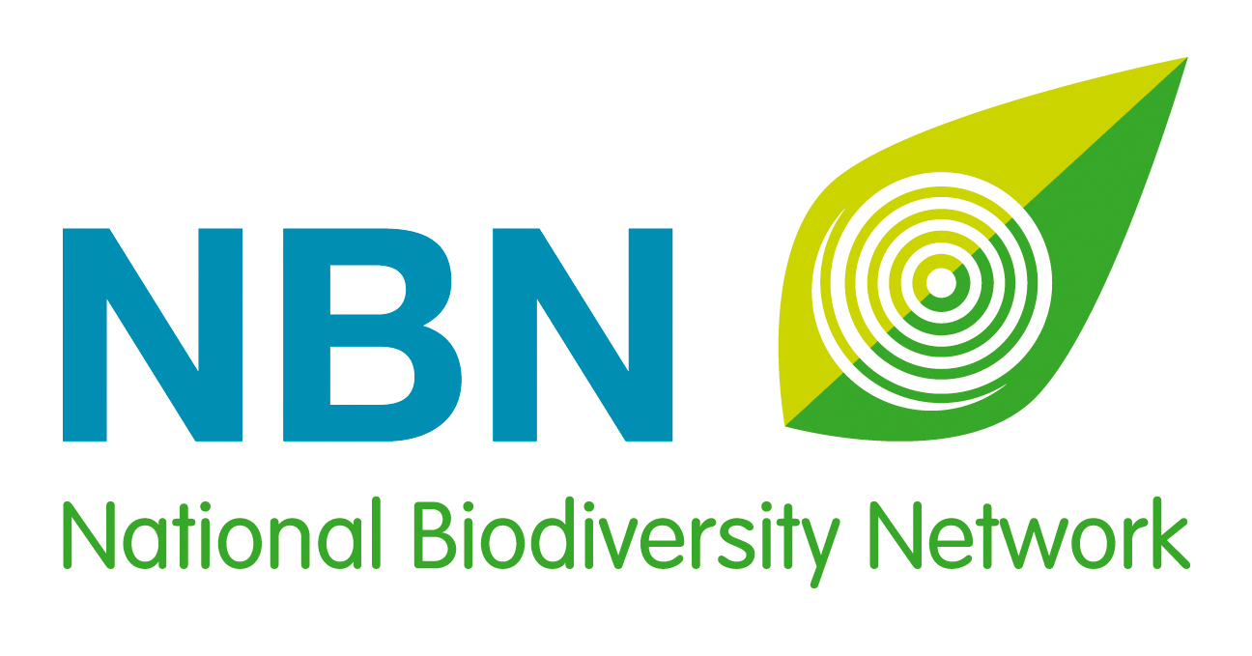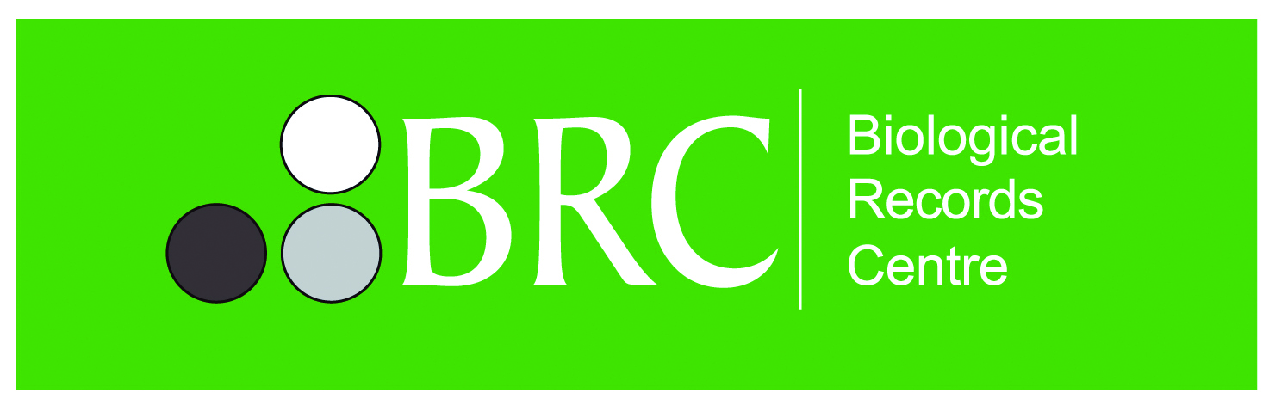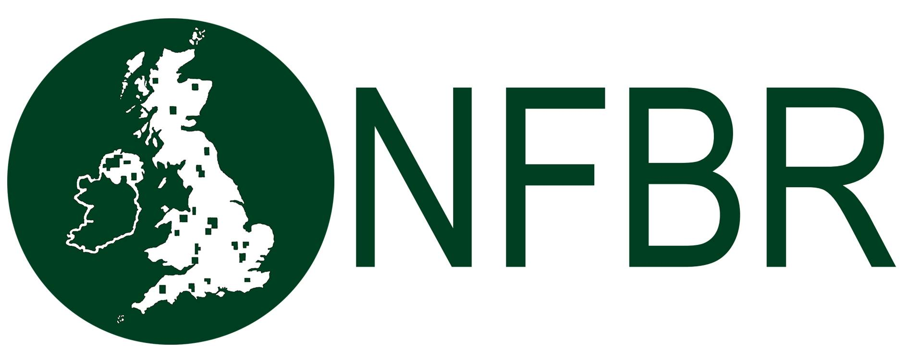

UK Awards for Biological Recording and Information Sharing 2017
gilbert white Adult aWARD Nomination form
Sponsored by:

The National Biodiversity Network is now accepting nominations for the 2017 Awards that celebrate outstanding contributions to biological recording and improving our understanding of the UK’s wildlife. These awards have been developed by the National Biodiversity Network, the National Forum for Biological Recording and the Biological Records Centre. The Gilbert White Adult Award is generously sponsored by Paramo.
The award categories are:
Terrestrial and freshwater awards:
- Gilbert White Youth Award
- Gilbert White Adult Award

Marine and coastal awards:
- David Robertson Youth Award
- David Robertson Adult Award

Lynne Farrell Group Award:
- This award will be given to a group or organisation which works in any environment - terrestrial and freshwater or marine and coastal.

Adult Newcomer Award:
- This award will be given to an adult who has recently started working or volunteering in the biological recording sector.

Eligibility for award categories:
- Youth awards will be given to a person not yet 18 years of age on 30th November 2017.
- Adult awards will be given to a person 18 years old and over.
- The groups or organisations can include members of any age.

The awards committee will consider the significance of the contribution (voluntary or otherwise) made to biological recording and/or improving our understanding of the UK’s biodiversity. This could include filling geographic or taxonomic gaps in our knowledge, encouraging and facilitating participation, verifying records, teaching or mentoring recorders, or creating and sharing tools and resources to support biological recording and increasing participation. More information about the awards and additional nomination forms are available on the National Biodiversity Network website: bit.ly/NBNawards
To nominate the same person for different award categories, please use the relevant nomination forms for each category. If you wish to nominate more than one person for the same award category, please use a separate form for each nominee. Anyone is eligible to make nominations, you may even nominate yourself! The awards will be presented at a special ceremony on the evening of the annual NBN Conference in November.
Nominations close on Monday 31st July 2017. The awards committee may ask for supplementary material to be supplied for short‐listed candidates.

NAME OF NOMINEE:
Address:

Phone:
E-mail:
REASONS FOR NOMINATION:
Please describe the contribution of the nominee and reasons for nomination. Please give as much detail as possible using the five headings below. The Awards Committee can only make its decision based on the information you supply, so the more relevant detail you provide under each heading, the more likely your nominee will do well in these Awards.
Increasing understanding
Has the work aided taxonomic or geographic understanding?
Has the work plugged gaps in taxonomic or geographical knowledge?

Record generation and open data
Are new records being made? Do they cover one taxonomic group or several?
Are the records being shared openly? Are they on the NBN Atlas?

Engagement and training
Has the nominee encouraged participation by others and developed new audiences for nature?
Is the nominee training others and increasing their skills?

Impact and influence
Are the data being used in policy, affecting decision-making?
Has the work carried out been game-changing? For example, have new tools or resources been developed or has a new organisation been established?

Uniqueness and other considerations
Is anyone else doing similar work in the same area?
Is the nominee self-taught? Are they a volunteer? Commitment over time/period of involvement?

Please add more details on separate pages if required.
YOUR NAME:
Relationship to nominee:
Your contact details:
Address:
Phone:
E-mail:
Please send your nomination form by Monday 31st July 2017 to: support@nbn.org.uk
☐ Please mark this box, if you would like to remain anonymous throughout the nomination and
Award process.

And finally, please could you tell us where you heard about these Awards?
(Please mark all that apply)

☐ NBN website ☐ Network News ☐ Facebook

☐ Twitter ☐ LinkedIn ☐ Instagram

☐ Poster ☐ Wildlife group/organisation ☐ Other

If other, please specify _________________________________________________________________ 

